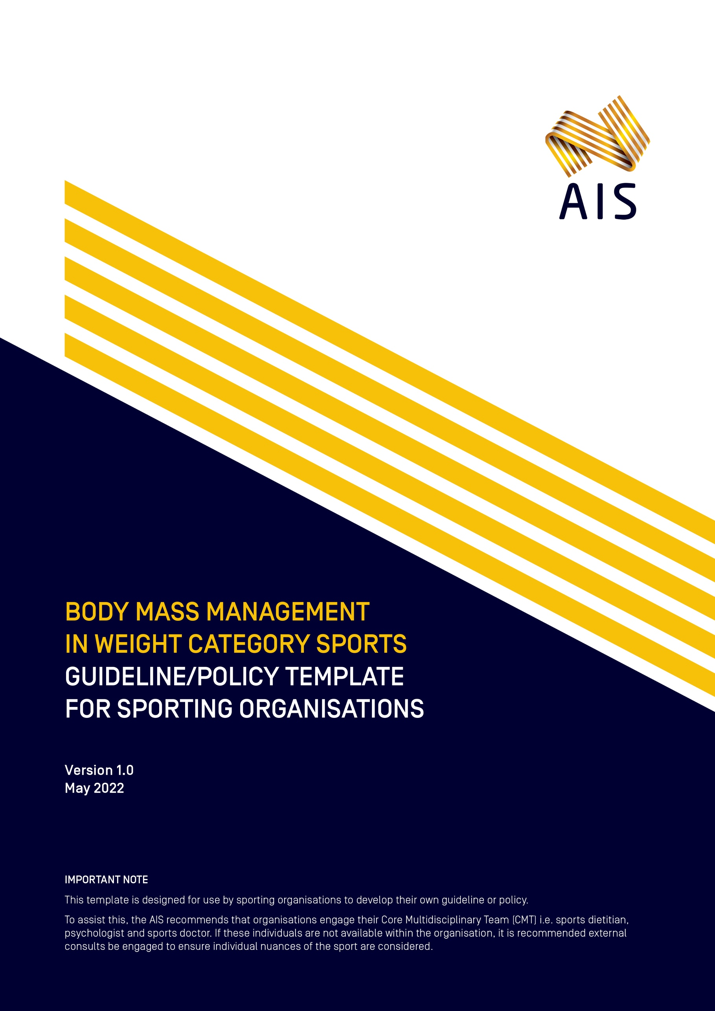
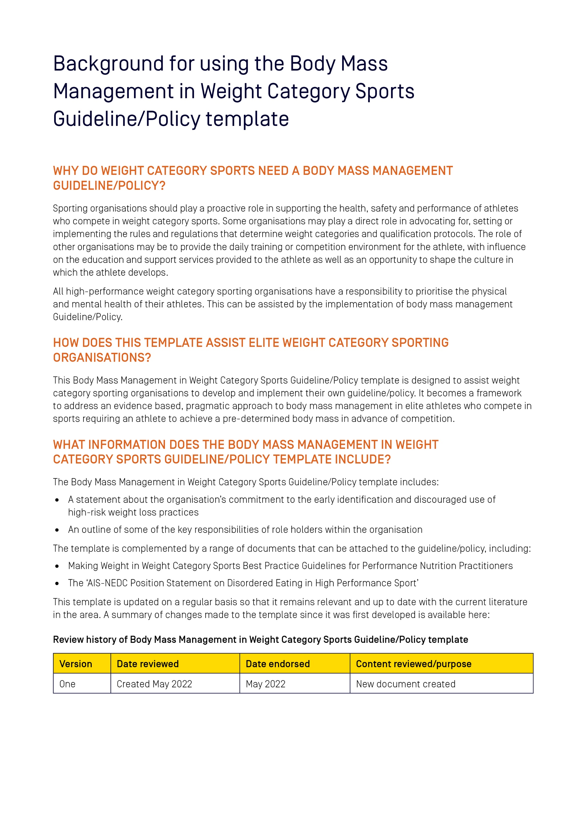
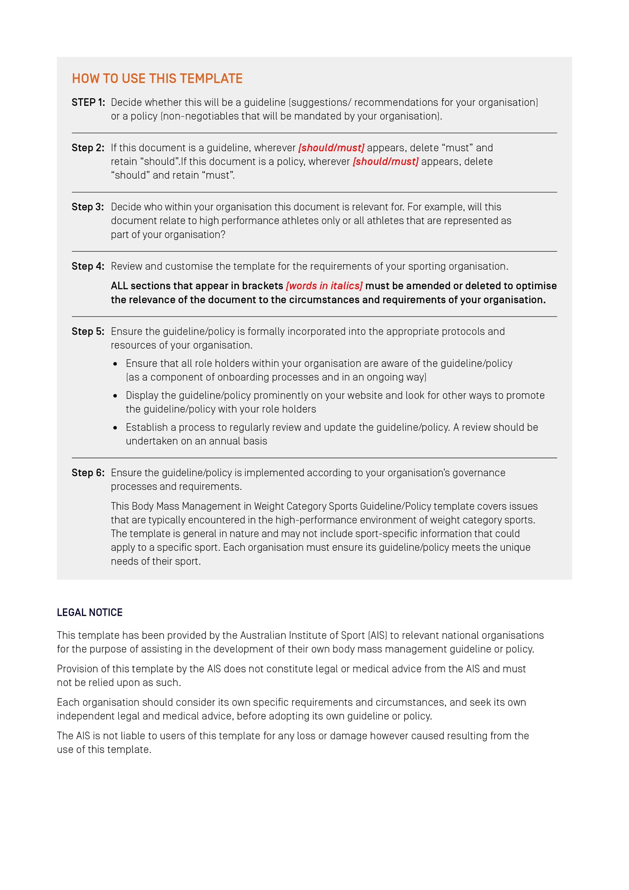
[Insert Organisation logo]

[Insert name of organisation]
Body Mass Management in Weight Category Sports
Guideline/Policy*
[*This template refers to either a policy OR a guideline. Decide which one
you wish to use and keep this term consistent throughout the document]

Version [insert version number]
[insert date created/updated]
Table of Contents
Preface 6
[Insert name of sporting organisation]’s Body Mass Management
in Weight Category Sports [Guideline/Policy] 7
Introduction 7
Purpose of this document 7
Organisational responsibilities 7
Individual responsibilities 8
Who does this [guideline/policy] apply to? 8
Breach of this [guideline/policy] [delete section if not appropriate to your sport] 8
1. Healthy sport system 9
The Core Multidisciplinary Team (CMT) 9
2. Management of body mass 11
Optimised nutrition 11
Low energy availability and other signs of Relative Energy Deficiency in Sport (RED-S) 11
Early identification 11
Body composition assessment 11
Use of language 11
3. Prevention of disordered eating 12
Education 12
Body image 12
4. Other considerations 13
Junior athletes 13
Female athletes 13

Preface
- [Include a statement here from the President or CEO demonstrating a clear commitment at the highest level of your organisation to providing a safe sporting environment that works proactively in the early identification and discouraged use of high-risk weight loss practices in athletes
The Preface could state:
- That your organisation seeks to provide a safe sporting environment that promotes a pragmatic, safety focused approach to body mass management that discourages use of high-risk weight loss practices
- That all role holders within the organisation, including athletes, family members, coaches and performance support staff, have a responsibility to support a safe sporting environment
- That all role holders have the right to expect that the sporting environment in which they work is safe and supportive
- That the guideline/policy sets out actions that are implemented by the organisation to assist in providing this safe sporting environment]

Signature of CEO/President
Name of CEO/President
Name of Sporting Organisation
Date

Review history of [insert name of organisation] Body Mass Management in Weight Category Sports [Guideline/Policy]

Version | Date reviewed | Date endorsed | Content reviewed/purpose
One | Created [insert month/year] | [insert month/year endorsed] | [insert summary of amendments]
Two | [insert month/year reviewed] | [insert month/year endorsed] | [insert summary of amendments]
Three | [insert month/year reviewed] | [insert month/year endorsed] | [insert summary of amendments]

[Insert name of sporting organisation]’s Body Mass Management in Weight Category Sports [Guideline/Policy]

Introduction
Weight category sports make up a significant proportion of the events on the Olympic Games program and represent sports with growing participation rates at community and high-performance level. Within such sports, athletes routinely attempt to gain a competitive edge by manipulating their body mass to compete in a division that is lighter than their normal training “weight”. Although strategies include long term changes in body composition, acute weight loss is typically undertaken in the period immediately before a competition weigh-in via dietary restriction, increased exercise, and other strategies that achieve moderate to severe dehydration. Acute weight loss practices may impair performance and result in serious health and safety risks. Tragically, athletes have died while “making weight” for competition.
[Insert name of sporting organisation] endorses the Australian Institute of Sport (AIS) Making Weight in Weight Category Sports Best Practice Guidelines.
[Insert any details of your organisation here that are appropriate. This may include athlete inclusion/exclusion criteria of who this document refers to]

Purpose of this document
The [insert name of sporting organisation] Body Mass Management in Weight Category Sports [Guideline/Policy] aims to assist our organisation to implement the practices required to provide a healthy sport system. The appropriate identification of an appropriate weight class and pragmatic approach to body mass management in our athletes is important in view of the significant ramifications of using high risk weight loss practices on an athlete’s health and performance. We prioritise the health and wellbeing of our athletes and believe all role holders in our sporting system have a part to play.
This [guideline/policy] has been endorsed by [insert name of NSO Board or Committee] and has been [insert relevant information e.g. incorporated into our constitute document, rules, regulations or by-laws]. The [guideline/policy] starts on [insert date] and will operate until replaced.
The current [Guideline/Policy] and its attachments can be obtained from our website at: [Insert website address].

Organisational responsibilities
[Insert name of sporting organisation] will:
- Adopt, implement and comply with this [guideline/policy].
- Ensure this [policy] is enforceable [delete this point if this is a guideline].
- Publish, distribute and promote this [guideline/policy].
- Promote and model appropriate standards of behaviour at all times.
- Deal with any complaints or concerns made under this [guideline/policy] in a timely manner.
- Deal with any breaches of this [guideline/policy] in an appropriate manner.
- Monitor and review this [guideline/policy] regularly.

Individual responsibilities
Individuals bound by this [guideline/policy] must:
- Make themselves aware of the contents of this [guideline/policy].
- Comply with all relevant provisions of the [guideline/policy].
- Place the health and wellbeing of athletes above other considerations.
- Be accountable for their behaviour.
- Seek to engage in upskilling in the area as required.

Who does this [guideline/policy] apply to?
This [guideline/policy] applies to all role holders within [insert name of sporting organisation] including but not limited to [amend any that are not applicable]:
- Athletes
- CEO and Board members
- Executive and corporate support staff (for example marketing and sponsorship, communications, administration, reception/front of house, human resources)
- High Performance Director
- Coaches
- Performance Support managers and practitioners
- [any other Athlete Support Personnel to whom the [guideline/policy] applies]
- For any other athletes, the purpose of this [guideline/policy] is to provide guidance and education in relation to best practice supplement use
[Insert name of sporting organisation] recommends that all State Institutes/Academies of Sport and Clubs adopt this [guideline/policy].

Breach of this [guideline/policy]
[delete section if not appropriate to your sport]
On occasions that this [guideline/policy] is not adhered to, appropriate action will be taken in accordance with the procedures outlined in [Insert name of organisation]’s [insert name of applicable disciplinary regulations document].

- Healthy sport system
A healthy sport system is needed to support and nurture our athletes. At [Insert name of sporting organisation] we support the values and actions in this document. The environment and culture at [Insert name of sporting organisation] plays an important role in creating a healthy sport system. We recognise that how we treat all members of our Organisation is important, most importantly our athletes. The appropriate management of body mass and related issues in our athletes are the outcomes of a healthy sport system and will be discussed individually in more detail below.

The Core Multidisciplinary Team (CMT)
[Insert name of organisation] recognises that the profession of the CMT provides a vital function in the appropriate identification of an appropriate weight class and pragmatic approach to body mass management in our athletes. For the high performance program, [Insert name of organisation] [should/will]:
- Establish a CMT (if it doesn’t already exist) of sports doctor, sports dietitian and psychologist.
- Develop communication channels within the CMT and from the CMT to the broader support team.
Editing note: align content within this point with guideline/policy application for your Organisation.
As per the Olympic Movement Medical Code, all activities of the CMT [should/must] be based on the premise that the health and welfare of athlete are pre-eminent and prevail over competitive, economic, legal or political considerations. Although there are many aspects to their roles within the environment of weight category sports including education and the development of relevant policy, special attention needs to be given to scenarios in which athletes should be supported or mandated to receive individual attention from members of the CMT. Recommendations are provided in the table on the following page.
A sports dietitian [should/must] be the first practitioner within the CMT an athlete engages to identify an appropriate weight category and then subsequently design, implement and refine weight making plans. Having access to psychological support will enable greater provision of services to athletes at risk of disordered eating, and a doctor will be best positioned to assess changes in general health/physiological status, as well as enable any necessary diagnostic tests (blood chemistry, bone mineral density scans etc.). Good communication within the CMT is critical for optimal outcomes to be achieved for the athlete. Together the CMT can leverage each other’s expertise to identify “at risk” athletes earlier in their progression to detrimental states.
Sports dietitians are referred to the Making Weight in Weight Category Sports Best Practice Guidelines for Performance Nutrition Practitioners.

Professional | Scenarios which require Professional expertise
Sports Dietitian | Any athlete who needs to reduce their body mass to make weight, but particularly:  - An athlete who is known to have difficulties with making weight or has expressed interest to qualify for a lower weight division  - An athlete, identified by another health professional, whose weight making practices are affecting their performance, physical or mental health, or lifestyle  - A junior athlete (< 18 y) who is in the exceptional circumstances where weight making might be considered
Psychologist | Any athlete who is identified as having mental or psychological health problems related to weight making or their general involvement in a weight category sport, including  - An athlete who is not making progress despite a structured plan for weight management  - An athlete who demonstrates concerning eating behaviours  - An athlete who demonstrates body image concerns  - An athlete who experiences large weight gains between competitions  - An athlete who expresses interest in competing in a lower weight division where this has been deemed a “borderline” decision following assessment of body composition and discussions with a sports dietitian  In addition:  - A junior athlete (<18 y) who is in the exceptional circumstances where weight making might be considered
Sports Doctor | Any athlete who is identified as having medical or health issues related to weight making or their general involvement in a weight category sport, including:  - A youth athlete (<18 y) who is in the exceptional circumstances where weight making might be considered  - An athlete who expresses interest in competing in a lower weight division where this has been deemed a “borderline” decision following assessment of body composition and discussions with a sports dietitian  - An athlete who is identified by a sports dietitian as needing diagnosis (blood testing) of suspected sub-optimal nutrient status  - Any athlete who is identified as having mental or psychological health problems related to weight making or their general involvement in a weight category sport, including  - An athlete who has reoccurring injury and/or illness  - An athlete who has suffered complications during the weight making process such as episodes of dizziness/fainting, stomach pains or nausea, full body cramps, changes in blood pressure, cessation of sweat response or altered cognition

- Management of body mass

Optimised nutrition
[Insert name of organisation] recognises that athletes [should/must] be able to access nutrition support that meets the criteria for optimised nutrition; a harmony between health and performance underpinned by concepts that are safe, supported, purposeful and individualised. An appropriately qualified and experienced Sports Dietitian [should/must] provide the nutritional education to athletes.
Editing note: align content within this point with guideline/policy application for your Organisation.

Low energy availability and other signs of Relative Energy Deficiency in Sport (RED-S)
[Insert name of organisation], recognises that weight loss will necessitate the creation of an energy deficit, which if severe can result in low energy availability (LEA). If this is sustained, the syndrome known as relative energy deficiency in sport (RED-S) can result, with significant health and performance implications. Athletes [should/must] be referred for appropriate professional assessment (or to the CMT where this exists within an organisation and is available to the athlete) and support in the circumstances below:
- Any athlete with known or suspected disordered eating;
- Any athlete with known or suspected LEA;
- Any athlete who is diagnosed with a bone stress injury and/or identified with menstrual dysfunction;
- Any athlete with recurrent injuries and/or illnesses.
Athletes who are identified in these categories [should/must] be provided with ongoing monitoring, support and
regular review.

Early identification
[Insert name of organisation] recognises that early identification of high-risk weight loss practices is important in reducing the risk to health and performance of inappropriate body mass management practices. Identification of an appropriate weight category is advocated, with a focus of this decision being placed on the athletes presenting body mass and composition, complemented by other pertinent factors such as available time for body mass manipulation, prior body mass management experiences, current diet and training load, plus presenting metabolic and mental state.

Body composition assessment
Where body composition plays a role in sports performance, this role can be understood and integrated into an appropriate personalised plan for each athlete. For athletes in weight category sports, body composition assessment is integral to the identification of an appropriate weight class. [Insert name of organisation] recognises that the assessment of body composition is a common part of athlete assessment, and needs to be appropriately implemented to safeguard the athlete’s health and well-being. Appropriate implementation includes a range of considerations including but not limited to the need for assessment, selection of assessment technique/s, implementation of protocols and dissemination and interpretation of results, plus appropriate athlete education.

Use of language
Positive language [should/must] be used when speaking with and about athletes and their bodies. Athletes, coaches and performance support staff [should/must] receive education around such language. [Insert name of organisation] believes all bodies deserve to be treated with respect, no matter their size, shape, composition, colour or ability. Before any athlete is asked to change their body (in either size or composition), the CMT, in conjunction with the coach [should/must] be consulted and involved in the decision making and communication process.

- Prevention of disordered eating
[Insert name of organisation] recognises simply participating in a weight category sport poses potential risks. Athletes in weight category sports often experience pressure to reduce body mass and body fat levels for sports performance. Furthermore, the absence of adequate support and sound management practices is often not questioned, in part because weight making has become an integral part of the culture of many weight category sports. Typically, these athletes have an increased risk for poor body image, disordered eating and eating disorders. As such, proactive prevention strategies are advocated via education, support for optimised nutrition and positive body image in athletes, and appropriate assessment of body composition.
See the Australian Institute of Sport (AIS) and National Eating Disorders Collaboration (NEDC) Position Statement on Disordered Eating in High Performance Sport.

Education
At [Insert name of organisation] we support the education of our coaches, performance support staff, athletes, and athlete support system to assist in early identification and prevention of disordered eating.

Body image
[Insert name of organisation] recognises that a positive body image is one of the protective factors that enable an athlete to be more resilient to developing disordered eating or an eating disorder. Appropriate support [should/must] be provided to athletes to encourage a positive body image, using activities targeted at groups and individuals. Positive body image in athletes is promoted through education and support for all roles holders at [Insert name of sporting organisation], not just in our athletes.

- Other considerations

Junior athletes
In view of the negative consequences of inappropriate weight management practices, [Insert name of organisation] promote the general principle that junior athletes (<18 years of age) [should/must] not engage in AWL in order to qualify for competition. Instead, young athletes are encouraged to adopt sound nutrition practices that promote good health, support their growth and overall development, and exclude a preoccupation with weight control. Given normal growth patterns, it is natural for a junior athlete to transition through several weight categories until they fully mature. It is recognised, in rare situations, a compelling case in which a junior athlete might need to engage in weight management practices could occur. For example, a talented young athlete who is undergoing a growth phase may exceed the weight division of the Olympic Games for which they have previously qualified several months earlier, rendering them unable to compete in the absence of BODY MASS manipulation. Such scenarios [should/must] be assessed, managed and closely monitored on a case-by-case basis. Furthermore, support [should/must] be provided to the athlete and their parents/guardians by the CMT of sports dietitian, sports doctor and psychologist.

Female athletes
Hormonal variations throughout the menstrual cycle can influence several physiological systems relevant to weight management in females, inclusive of body composition, substrate utilization, fluid balance and thermoregulation. Given this, gender should be considered when exploring both chronic and acute weight loss strategies, plus recovery following weigh-in. For example, females appear to be more vulnerable to adverse health and performance implications of sustained periods of dietary restriction and/ or training excesses. As such, energy intake [should/must] be prescribed to ensure rates of weight loss not greater than 1% weekly. potentially further increasing the risk of heat stress if female athletes are exposed to thermal challenges to support weight loss during this phase of their menstrual cycle. As such, it is pertinent to examine either the use of contraception or menstrual cycle status, in conjunction with any potential underlying health issues related to energy availability when working with female athletes.
[Insert name of organisation] recognises the importance of normal menstrual function in our female athletes. [Insert name of organisation] encourages athletes to monitor their menstrual function from a health perspective. Any menstrual irregularities [should/must] be investigated with a doctor.

