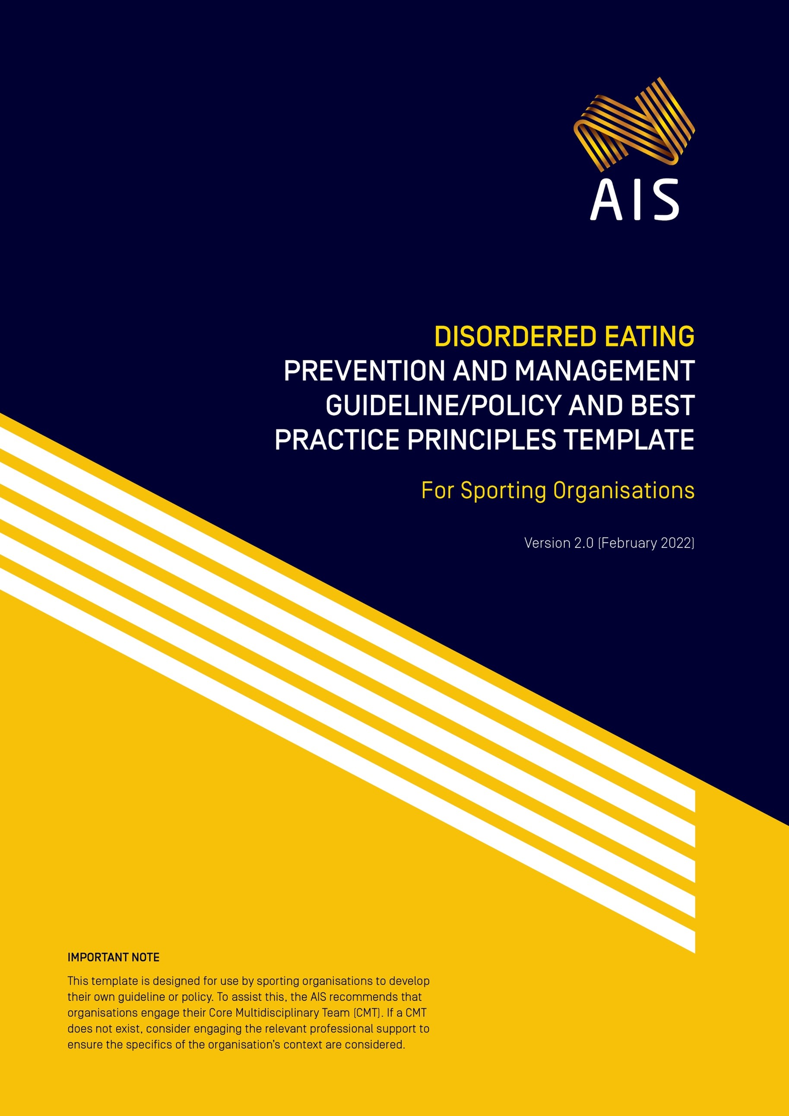

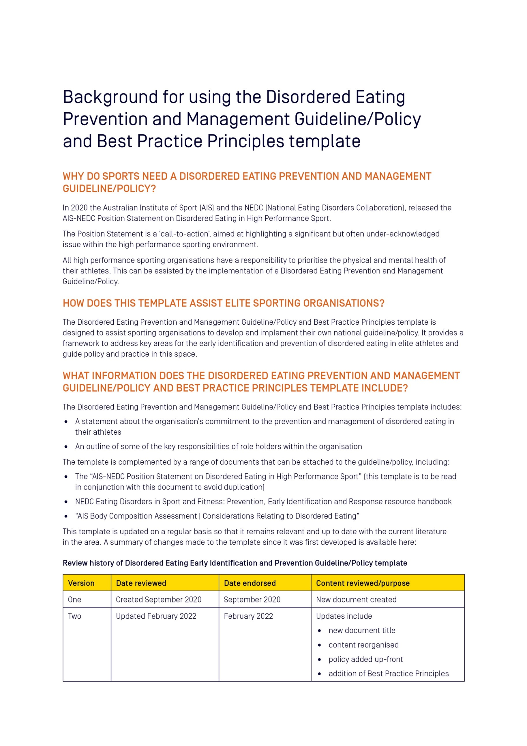

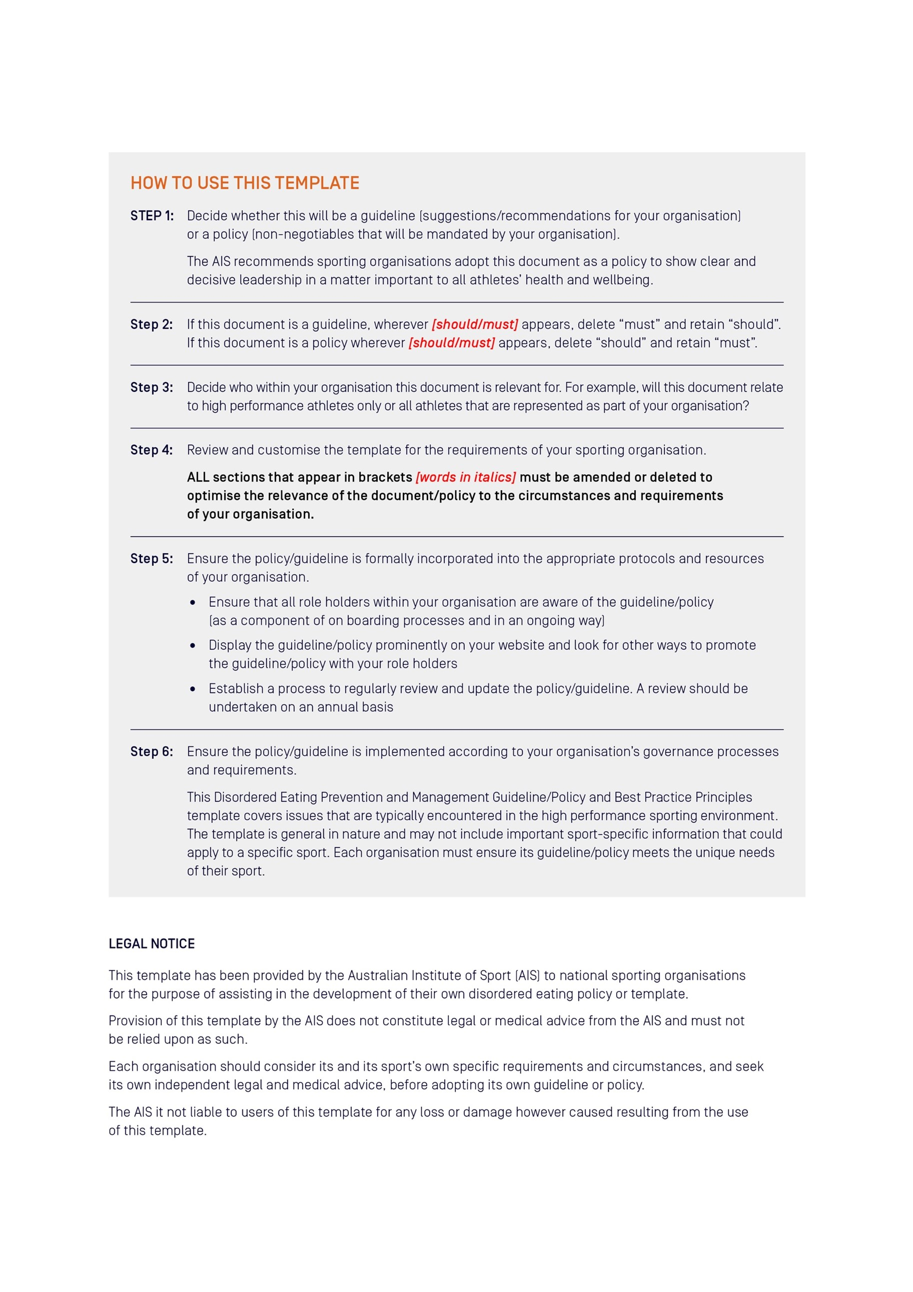

[Insert Organisation logo]

[Insert name of organisation]
Disordered Eating Prevention and Management Guideline/Policy* and Best Practice Principles
[*This template refers to either a policy OR a guideline. Decide which one
you wish to use and keep this term consistent throughout the document.]

Version [insert version number]
[insert date created/updated]
Table of Contents
Preface 7
[Insert name of sporting organisation]’s Disordered Eating Prevention and Management [Guideline/Policy] 8
Organisational responsibilities 8
Individual responsibilities 8
Who does this [guideline/policy] apply to? 8
[Insert name of sporting organisation]’s Disordered Eating Prevention and Management Best Practice Principles 10
Introduction 10
Purpose of this document 10
1. Healthy sport system 11
The Core Multidisciplinary Team (CMT) 11
2. Primary prevention of disordered eating 12
Education 12
Optimised nutrition 12
Role of body composition 12
Body image 12
Use of language 12
Use of images of athletes 13
High risk populations, contexts and environments 13
3. Secondary prevention of disordered eating 15
Early detection 15
Screening tools 15
Menstrual function in female athletes 15
Low energy availability and other signs of Relative Energy Deficiency in Sport (RED-S) 15
4. Tertiary prevention of eating disorders 16
Eating disorder diagnosis 16
Eating disorder treatment 16
Comorbidity with mental health conditions 16
Return to play 16
Prevention of complications relating to eating disorders 16
5. Appendix 17
Appendix 1: Definitions and abbreviations 17
Appendix 2: The AIS-NEDC position statement on disordered eating in high performance sport 18
Appendix 3: AIS or Organisations own Body Composition Assessment | Considerations Relating to Disordered Eating 18
Appendix 4: AIS Female Performance & Health Initiative | Understanding Your Menstrual Cycle: What’s Normal, What’s Not? 18
Appendix 5: RED-S Return to Play Clinical Assessment Tool 18

Preface
[Include a statement here from the President or CEO demonstrating a clear commitment at the highest level of your organisation to providing a safe sporting environment that works proactively for the prevention, early identification and appropriate management of disordered eating and eating disorders in athletes.
The Preface could state:
- That your organisation seeks to provide a safe sporting environment that is proactive in the prevention, early identification, and appropriate management of eating disorders
- That all role holders within the organisation, including athletes, family members, coaches and performance support staff, have a responsibility to support a safe sporting environment
- That all role holders have the right to expect that the sporting environment in which they work, train and compete is safe and supportive
- That the guideline/policy sets out actions that are implemented by the organisation to assist in providing this safe sporting environment]

Signature of CEO/President
Name of CEO/President
Name of Sporting Organisation
Date

Review history of [insert name of organisation] Disordered Eating Prevention and Management [Guideline/Policy] and Best Practice Principles
Version | Date reviewed | Date endorsed | Content reviewed/purpose
One | Created [insert month/year] | [insert month/year endorsed] | [insert summary of amendments]
Two | [insert month/year reviewed] | [insert month/year endorsed] | [insert summary of amendments]
Three | [insert month/year reviewed] | [insert month/year endorsed] | [insert summary of amendments]

[Insert name of sporting organisation]’s Disordered Eating Prevention and Management [Guideline/Policy]

Organisational responsibilities
The [Insert name of sporting organisation] will:
- Adopt, implement, and comply with the [Insert name of sporting organisation] Prevention and Management Best Practice Principles.
- Publish, distribute, and promote the [Insert name of sporting organisation] Prevention and Management Best Practice Principles.
- Monitor and review the [Insert name of sporting organisation] Prevention and Management Best Practice Principles.

Individual responsibilities
[Insert name of sporting organisation] employees and other persons who agree to be bound by this guideline/policy must:
- Make themselves aware of the contents of the [Insert name of sporting organisation] Prevention and Management Best Practice Principles.
- Comply with all relevant provisions of the [Insert name of sporting organisation] Prevention and Management Best Practice Principles.
- Seek to engage in upskilling in the area as required to enable them to perform their role.
  - [Insert name of sporting organisation] CMT Members may need to access professional development and clinical supervision.

Who does this [guideline/policy] apply to?
This [guideline/policy] applies to all role holders within [insert name of sporting organisation] including but not limited to [amend any that are not applicable]:
- Athletes
- Family and athlete support system
- CEO and Board members
- Executive and corporate support staff (for example marketing and sponsorship, communications, administration, reception/front of house, human resources)
- High Performance Director
- Coaches
- SSSM Manager, Performance Health Manager
- AW&E Manager/Advisor
- The DE Core Multidisciplinary Team (CMT) of psychologist, doctor and sports dietitian
- Sports Science Sports Medicine (SSSM) Practitioners (for example biomechanists, performance analysts, skill acquisition staff, soft tissue therapists, physiotherapists, strength and conditioning coaches, physiologists)
- [any other person to whom the guideline/policy applies]
[Insert name of sporting organisation] recommends that all State Institutes/Academies of Sport and Clubs adopt this [guideline/policy].

This [guideline/policy] has been approved by the [Insert name of Executive or Board that has approved the document] and starts on [insert date] and will operate until replaced.
The current document and its attachments can be obtained from our website at: [insert web location of document here]

[Insert name of sporting organisation]’s Disordered Eating Prevention and Management Best Practice Principles

Introduction
Disordered eating (DE) and eating disorders (EDs) are serious and complicated issues that can impact the health and performance of athletes across the high performance pathway, from junior to senior levels. Eating disorders can occur in any athlete, in any sport, at any time. Defined terms used in these principles are set out in Appendix 1. The [Insert name of sporting organisation] Disordered Eating Prevention and Management [guideline/policy] and Best Practice Principles is to be read in conjunction with the Australian Institute of Sport (AIS) and the National Eating Disorders Collaboration (NEDC) Disordered Eating in High Performance Sport Position Statement (see Appendix 2).
[Insert any details of your organisation here that are appropriate. This may include athlete inclusion/exclusion criteria of who this document refers to.]

Purpose of this document
The [insert name of sporting organisation] Disordered Eating Prevention and Management Best Practice Principles aims to allow [insert name of sporting organisation] to model the practices required to create and provide a healthy sport system within the unique [insert name of sporting organisation] environment. The appropriate prevention, early identification and management of DE and EDs in athletes is important in view of the significant ramifications on an athlete’s health (both mental and physical) and performance. [Insert name of sporting organisation] prioritises the health and wellbeing of our athletes and believes all role holders in our sporting system have a part to play.

- Healthy sport system
A healthy sport system is needed to support and nurture our athletes. At [Insert name of sporting organisation] we support the values and actions in this document. The environment and culture at [Insert name of sporting organisation] plays an important role in creating a healthy sport system. We recognise that how we treat all members of our organisation is important, most importantly our athletes.
The prevention framework of primary, secondary and tertiary treatment approaches are needed for the appropriate management of DE and the outcomes of a healthy sport system. Each will be discussed individually in more detail below.

The Core Multidisciplinary Team (CMT)
[Insert name of organisation] recognises that the professions within the CMT provide a vital function in the early identification, assessment, diagnosis, treatment (where appropriate) and referral (as required) of DE and EDs. There are times when the CMT might include members from within [Insert name of organisation], from NINs, and/or from external treatment teams. [Insert name of organisation] [should/will] have:
- An established CMT of doctor, sports dietitian and psychologist.
- Clear and flexible communication channels within the [Insert name of organisation] CMT to the broader support team. This includes, where appropriate, communication with non-[Insert name of organisation] support team members as well as specialty ED services.
- In most circumstances, decisions on management of an athlete with DE or an ED will usually be by consensus of the CMT members. The medical practitioner within the CMT will however retain the responsibility for key decisions in the management of the athlete.
Editing note: align content within this point with application for your Organisation.

- Primary prevention of disordered eating
Primary Prevention is defined as actions taken to reduce the risk of developing a condition and also aims to specifically remove causal factors for the development of the condition. To implement Primary Prevention of ED, [Insert name of organisation] recognises the ideal of preventing EDs within the high performance sporting environment and will provide education, support for optimised nutrition and positive body image in athletes, and appropriate assessment of body composition to achieve primary prevention outcomes.

Education
Education relating to eating disorders is paramount to their overall prevention and management. The evidence suggests that providing education relating to eating disorder risk factors, development, signs and symptoms will raise awareness and literacy in the area. Further, we believe that education of all role holders of the management strategies will enable appropriate courses of action. Where appropriate, [Insert name of organisation] will provide this education to athletes and/or coaches and performance support staff. Eating Disorders in Sport (EDiS) is a workshop for coaches and performance support staff, has been co-developed by the AIS and NEDC and will be delivered within [Insert name of organisation] as appropriate.

Optimised nutrition
Athletes accessing nutrition support through [Insert name of organisation] [should/must] have optimised nutrition support, a harmony between health and performance underpinned by concepts that are safe, supported, purposeful and individualised. An appropriately qualified and experienced Sports Dietitian [should/will] be engaged to provide any nutritional education to athletes.
Editing note: align content within this point with guideline/policy application for your Organisation.

Role of body composition
Where body composition plays a role in sports performance, this role can be understood and integrated into an appropriate personalised plan for each athlete. [Insert name of organisation] recognises that the assessment of body composition is a common part of athlete assessment and needs to be appropriately implemented to safeguard the athlete’s health and well-being. Appropriate implementation includes a range of considerations including but not limited to the need for assessment, selection of assessment technique/s, implementation of protocols and dissemination of results.
See [Insert name of sporting organisation link here or link to AIS body composition considerations document] for further details. These considerations [should/must] be followed whenever body composition assessment techniques are utilised.

Body image
[Insert name of organisation] recognises that a positive body image is one of the protective factors that enable an athlete to be more resilient to developing DE or an ED. Appropriate education and/or support [should/will] be provided to athletes to encourage a positive body image, using activities targeted at groups and individuals as appropriate. Positive body image in athletes is promoted through education and support for all roles holders at [Insert name of sporting organisation], not just for athletes but coaches and performance staff as well.

Use of language
Respectful language [should/must] be used when speaking with and about athletes and their bodies. Athletes, coaches and performance support staff [should/must] receive education around such language. [Insert name of organisation] believes all bodies deserve to be treated with respect, no matter their size, shape, composition, colour or ability. Before any athlete is asked to change their body (in either size or composition), the [Insert name of organisation] CMT [should/must] be consulted and involved in the decision making and communication process.

Use of images of athletes
[Insert name of organisation] will focus on using images that encourage positive body image and aim to avoid images that may motivate some people or athletes at risk to strive to achieve an unrealistic shape, weight, or size. Noting that athletes across different sports have a wide range of body weights, shapes or body composition, images showing body diversity are encouraged. Priority will be given to images that identify the athlete or show them undertaking sporting activity, rather than images where it can be perceived the focus is on body composition.

High risk populations, contexts and environments

Transition periods
[Insert name of organisation] recognises that there are a number of transition periods in an athlete’s life that may place them at an increased risk of DE including, but not limited to:
- Early start of sport specific training
- Making a senior team at a young age
- Retirement (forced or voluntary)
- Non-selection or de-selection
- Injury, illness, surgery, time away from sport and training
- Changes in weight and/or body shape following injury or illness
- Major life transitions e.g., moving away from home, moving between schools, moving overseas;
- Preparation for and competing in a benchmark event (e.g., in the selection process, the period prior to the event, during and after the event)
At [Insert name of sporting organisation] we [should/will] identify states of elevated risk and apply appropriate support around the athlete at these times, with activities involving the coach, support staff or the CMT directly.

Working with minors
Working with minors requires appropriate care and consideration for this population. See [Insert name of organisation’s Child Safe Sport document here] for more details.
Whilst DE can occur at any age, [Insert name of organisation] understands that adolescence is a formative time in the development of an athlete’s body image and eating behaviour. Athletes in this age group [should/will] be provided with appropriate education and support to assist in the development of optimal body image and eating behaviours.
A registered medical professional is responsible for determining if and when an under-age athlete’s family will be informed of DE or an ED, subject to applicable privacy laws.

Para athletes
Para athletes have unique considerations around body image and eating behaviour. Where appropriate, the CMT [should/will] work individually with each para athlete and their coach and performance support staff to ensure that the needs of the athlete are met.

Making weight [delete section if not appropriate to your sport]
‘Making weight’ for weight categories/targets increases the risk of body image dissatisfaction, DE and EDs in athletes. Athletes involved in making weight sports [should/will] be provided with appropriate support including regular and ongoing access to the CMT.

Travel
[Insert name of organisation] has an important role in ensuring a safe environment for athletes undertaking travel.
- An athlete known to have an ED [should/must] have travel clearance from the CMT within their relevant treatment team.
- If an athlete is identified as having a potential ED while travelling, the [Insert name of organisation] doctor in charge (whether they are travelling with the team or not) may send the athlete home if it is in their best interests, physically and/or mentally.
- Where an athlete’s DTE is overseas, the CMT of [Insert name of organisation] and the CMT in the athlete’s DTE [should/will] work together to ensure due care and appropriate access to the required medical, nutritional and psychological support.

- Secondary prevention of disordered eating
The average time to diagnosis in an athlete with an eating disorder is more than nine years. [Insert name of organisation] has taken steps to reduce the time to diagnosis. Secondary prevention strategies aim to identify athletes with clinical or subclinical eating disorders at the earliest possible stage, where management is likely to be most effective.

Early detection
[Insert name of organisation] recognises that early identification of changes in an athlete’s thoughts around their body image and/or eating behaviours (along the spectrum of eating behaviour) is important in allowing a greater opportunity for reversal and recovery. Timely identification and early intervention are ideal.
Early detection can be achieved through population level screening of high-risk cohorts or through universal (all) programs. Early detection can be achieved through self-assessments (e.g., self-examination programs for breast cancers as an example in other conditions) or through symptom checklists (e.g., COVID19 symptom checklists that alert someone to seek help).

Screening tools
Screening tools will be used where appropriate within the [Insert name of organisation] environment. Where DE or an ED is suspected with an athlete in the care of [Insert name of organisation], clinical interviews with the appropriate CMT will be organised.

Menstrual function in female athletes
[Insert name of organisation] recognises the importance of normal menstrual function in our female athletes. [Insert name of organisation] encourages athletes to monitor their menstrual function from a health perspective. In the case where any menstrual irregularity is identified, it is strongly recommended these be investigated with a doctor who has experience working with female athletes within an appropriate timeframe. See Appendix 4 for further details.

Low energy availability and other signs of Relative Energy Deficiency in Sport (RED-S)
DE can occur in isolation or in combination with low energy availability (LEA), and their interaction and associated forms of presentation [should/must] be properly identified. Role holders covered within this [policy/guideline] are required to refer athletes for care. Athletes with known or suspected DE [should/must] be referred to the CMT for appropriate professional assessment and support. Referral to the CMT should be considered in the circumstances below:
- An athlete with known or suspected LEA
- An athlete who is diagnosed with a bone stress injury
- An athlete identified with menstrual dysfunction
- An athlete with more than one injury and/or illness within a 12-month period

- Tertiary prevention of eating disorders

Eating disorder diagnosis
The first component of tertiary prevention is to gain a correct diagnosis. [Insert name of organisation] recommends a clinical interview by an appropriately qualified professional, of which, should include medical oversight.

Eating disorder treatment
Treatment of an athlete with a diagnosed eating disorder may be most appropriate through an eating disorder specialist service (for example an ED clinic, or ED treatment team/unit), independent of [Insert name of organisation] and the high performance sporting environment. There are times however where it may be appropriate for one or more members of the [Insert name of organisation] CMT to be involved in an athlete’s ED treatment. [Insert name of organisation] [should/will] support and enable our CMT to undertake this role as required.

Comorbidity with mental health conditions
Eating disorders are often comorbid with other mental health concerns for example, depression, anxiety, stress and trauma. Other mental health concerns for example, depression, anxiety, stress and trauma are risk factors for developing disordered eating or an eating disorder. Therefore, it is important to promote overall mental health and wellbeing of the athlete and to have mental health support available for a range of presentations. On diagnosis, the [Insert name of organisation] Doctor may refer the athlete to a Psychiatrist for a diagnostic psychiatric interview, to ascertain any comorbidity for inclusion in the management plan.

Return to play
There are currently no specific DE or ED return to play guidelines. A [Insert name of organisation] athlete identified with DE may need training modifications or exclusions to minimise the risk of potential injury and/or illness. The [Insert name of organisation] CMT [should/ will] work as appropriate with any external ED treatment team, coaches and other performance team members to ensure an individual approach is taken to the athletes training regime.
See Appendix 5 for RED-S Clinical Assessment Tool (CAT) as an example of an exclusion and return to play guideline.

Prevention of complications relating to eating disorders

Prevention of recurrence, relapse and regression of symptoms
Athletes diagnosed and receiving treatment for an ED should undergo management plans for their career. Management does not cease when active treatment does. This should be communicated to the athlete and appropriate self-management tools provided at the clinically appropriate time.

Prevention of retirement
In some, but not all cases, retirement from high performance sport may occur due to health and safety concerns. While all care will be provided to the athlete to minimise the risk of this occurring, the outcome may still present. [Insert name of organisation] will provide resources to assist the athlete in this transition via available support networks and programs.

Prevention of subsequent health problems
While an athlete is under management by the CMT, there is an opportunity to provide prevention plans to reduce risk of serious consequences of the ED. A deficit in energy balance, related to the ED may present as injury or illness. Therefore, best practice management should include strategies to manage and where possible mitigate the risk of adverse health outcomes cause by the primary condition of ED.

- Appendix

Appendix 1: Definitions and abbreviations
Body image – the perception that an athlete has about their physical self and the thoughts and feelings that result from that perception.
Positive body image – occurs when an athlete is able to accept, appreciate and respect their body. A positive body image is one of the protective factors that can make an athlete more resilient to developing an eating disorder.
Body image dissatisfaction – occurs when an athlete has negative thoughts and feelings about their body and can result in a fixation on trying to change their body. This can lead to unhealthy food and exercise practices and increase the risk of developing an eating disorder.
Core-Multidisciplinary Team (CMT) – A team of professional practitioners (doctors, sports dietitians, psychologists) who collaborate in the management of disordered eating cases. In the Australian case this would be a Sports Doctor or General Practitioner, an Accredited Sports Dietitian and a Registered Psychologist or Endorsed Sport Psychologist.
Energy availability (EA) – the amount of energy that is available to support the body’s activities for health and function once the energy commitment to exercise has been subtracted from dietary energy intake. Energy availability = (Energy intake – Energy cost of exercise)/Kg fat free mass.
Low energy availability (LEA) – occurs when there is a mismatch between energy intake and exercise load, leaving insufficient energy to cover the body’s other needs. It may arise from inadequate energy intake, increased expenditure from exercise, or a combination of both; and is either advertent or inadvertent.
Relative energy deficiency in sport (RED-S) – the syndrome of impaired physiological function including, but not limited to, metabolic rate, menstrual function, bone health, immunity, protein synthesis, cardiovascular health that arises from low energy availability.
Prevention Framework
Primary prevention – improving the overall health of the athletic population with the goal of preventing an athlete from developing an eating disorder.
Secondary prevention – early detection of an eating disorder with the goal of preventing it from getting worse.
Tertiary prevention – improving quality of life and reducing the symptoms of an eating disorder for an athlete with an eating disorder diagnosis.
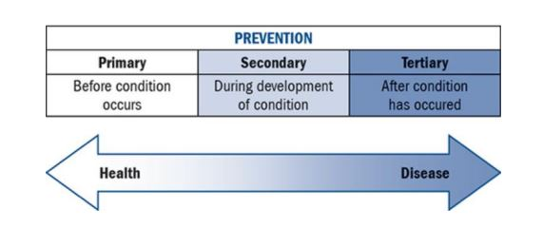
Spectrum of eating behaviour – in the high performance athlete from optimised nutrition to disordered eating to an eating disorder. All athletes sit on this spectrum and individuals move back and forth along the spectrum at different stages of their career, including within different phases of a training cycle.
Optimised nutrition – involves a safe, supported, purposeful and individualised approach. It promotes healthy body image and thoughts about food, and is adaptable to the specific and changing demands of an athlete’s sport.
Disordered eating (DE) – any eating behaviour that is not optimised. DE may range from what is commonly perceived as normal dieting to reflecting some of the same behaviour as those with eating disorders, but at a lesser frequency or lower level of severity. DE can occur in any athlete, in any sport, at any time, crossing boundaries of gender, culture, age, body size, culture, socioeconomic background, athletic calibre and ability.
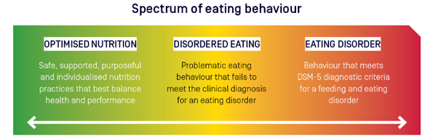
Eating disorder (ED) – A serious, but treatable mental illness with physical effects that can affect any athlete. Feeding and eating-related disorders are defined by specific criteria published in the diagnostic and statistical manual of mental disorders (DSM-5) which include problematic eating behaviours, distorted beliefs, preoccupation with food, eating and body image, and result in significant distress and impairment to daily functioning (e.g., sport, school/work, social relationships).

Appendix 2: The AIS-NEDC position statement on disordered eating in high performance sport

Appendix 3: AIS or Organisations own Body Composition Assessment | Considerations Relating to Disordered Eating

Appendix 4: AIS Female Performance & Health Initiative | Understanding Your Menstrual Cycle: What’s Normal, What’s Not?

Appendix 5: RED-S Return to Play Clinical Assessment Tool

