  - COMMITTING TO WIN WELL
November 2024

Dear Chief Executive Officer / Vice Chancellor / Director of Sport,

As we head to Milan/Cortino Winter Games and prepare for the LA2028 cycle, we would like to invite you to join the National Sporting Organisations and Tertiary Partners that have made the commitment to Win Well.
Building up to the Brisbane 2032 Olympic and Paralympic Games, we have a generational opportunity to achieve sustainable success for Australian sport over the next decade and beyond. As a High Performance Sporting System we are aligned to the HP2032+ Win Well Strategy (www.winwell2032.au) and commit to win well to inspire Australians.
Win Well acknowledges the importance of success and rewarding High Performance, and it highlights wellbeing as the foundation of sustainable success. By prioritising and focusing on the physical, mental, emotional, and cultural wellbeing of our athletes, coaches, staff, and sport as a whole, we will unlock our full potential and Win Well.
The Win Well Pledge is a genuine collective commitment from our leaders in sport from the HP 2032+ Sport Strategy. It brings the Strategy vision to life and holds us all accountable. By making this commitment your organisation is committing to delivering outcomes well beyond competition arenas.
Signing the Pledge also addresses one of the eight criteria that determines an institutions eligibility to the Elite Sport Education Network (ESEN).
To visibly demonstrate your organisation's commitment to the pledge we would like to invite you to sign your commitment to Win Well and return a copy to winwell@ausport.gov.au.
We would like to thank you in advance for making a commitment to Win Well to inspire Australians.
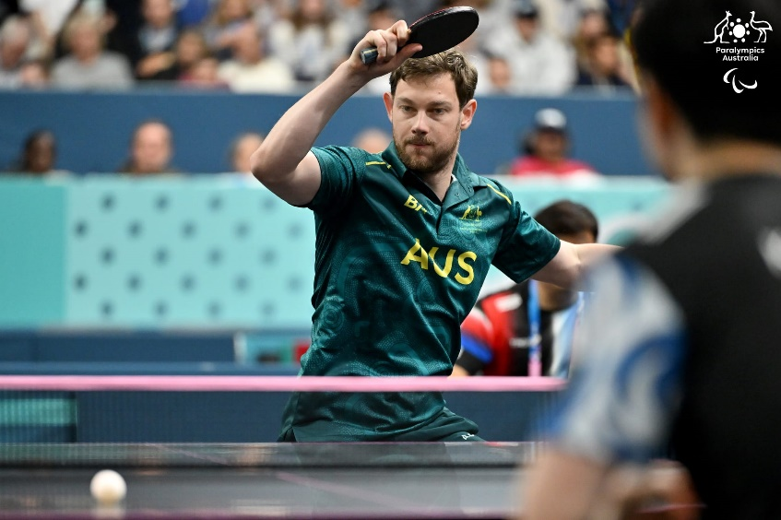
Image: Paralympics Australia

  - OUR COMMITMENT TO WIN WELL
We commit to being an organisation that strives to win well, where how we win is just as important as when we win.
We commit to the holistic development of our athletes and our staff, recognising wellbeing as the foundation of sustainable success.
We commit to leading sport with integrity, where we are accountable for the culture we foster and the decisions we make.
We commit to acknowledging and learning from Aboriginal and Torres Strait Islander Peoples and their cultures, and to walk together as we embed their knowledge and experience into our organisation and build a greater sense of belonging and connection to communities and country.
We commit to a culture of challenge and care so our athletes and staff can perform at their best and reach their potential.
We commit to creating safe and thriving environments for our people to fail so they can learn, grow and succeed.
We commit to being custodians of sport and building a legacy where sport is more inclusive and representative of the diversity of Australian communities.
We commit to Win Well.

Signature:
Name: | Click or tap here to enter text.
Title: | Click or tap here to enter text.
Organisation: | Click or tap here to enter text.

