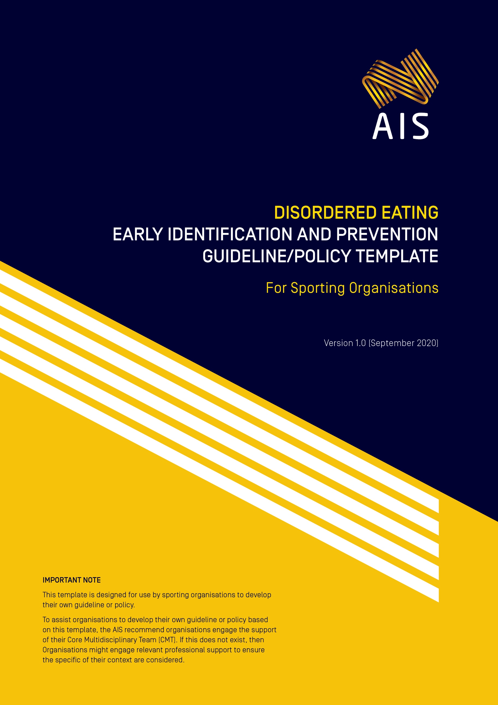

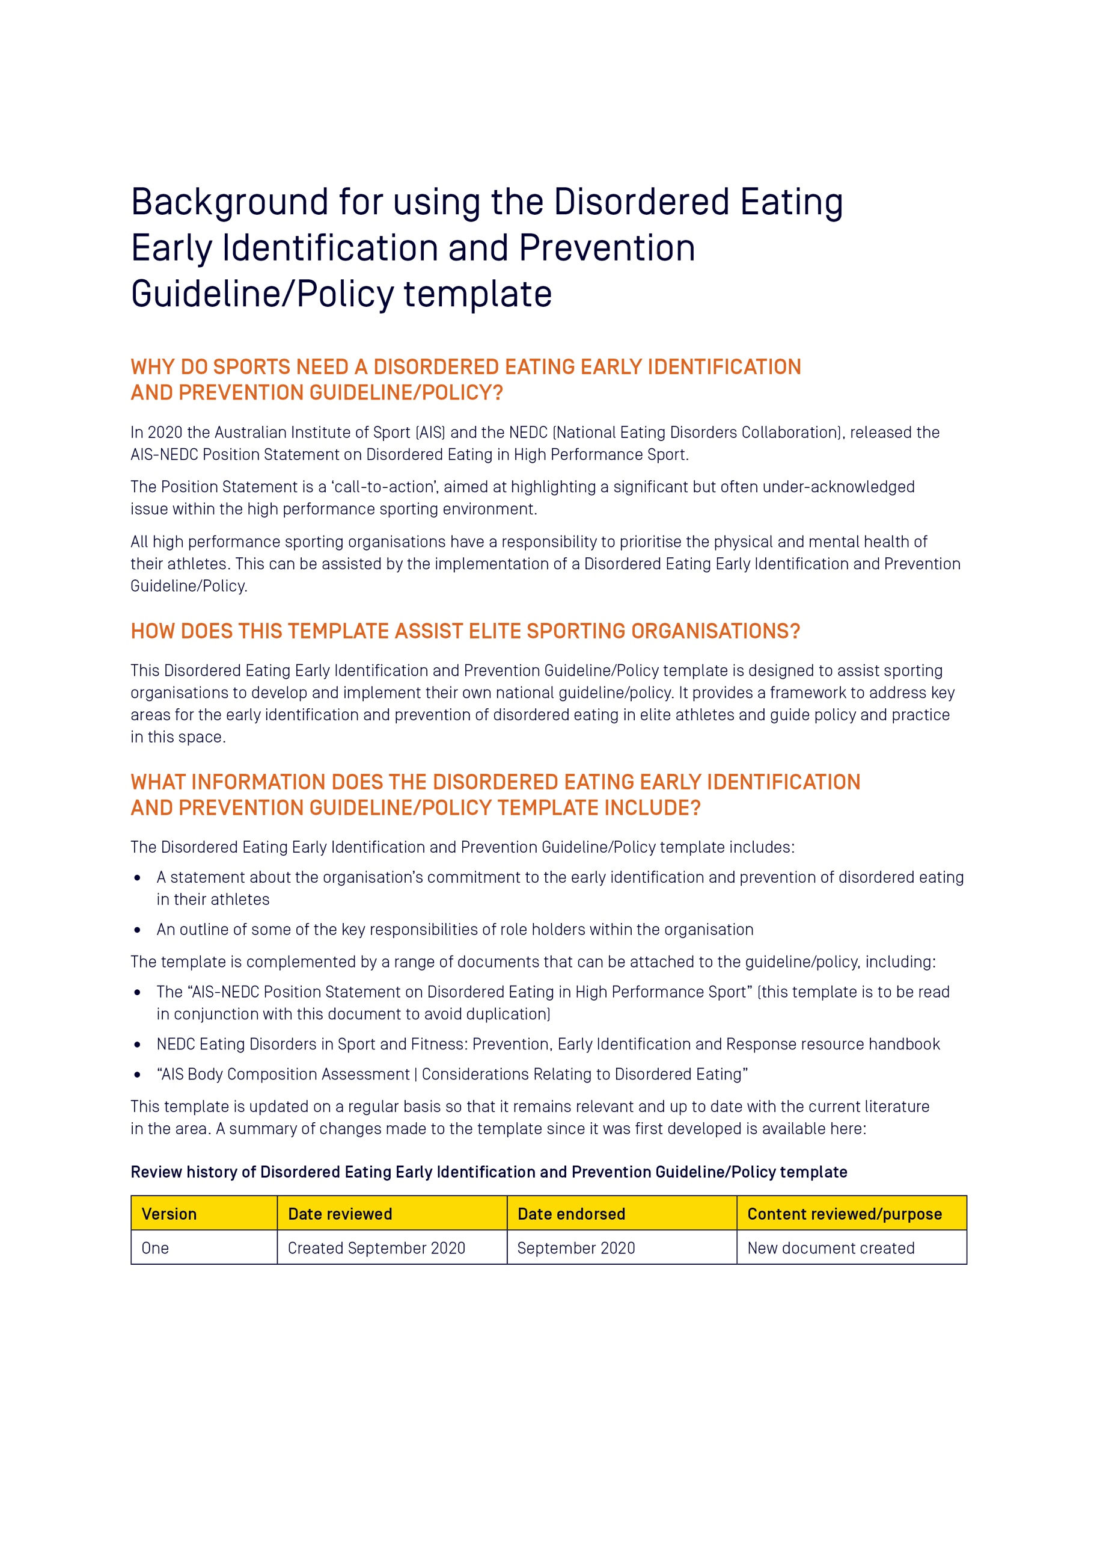

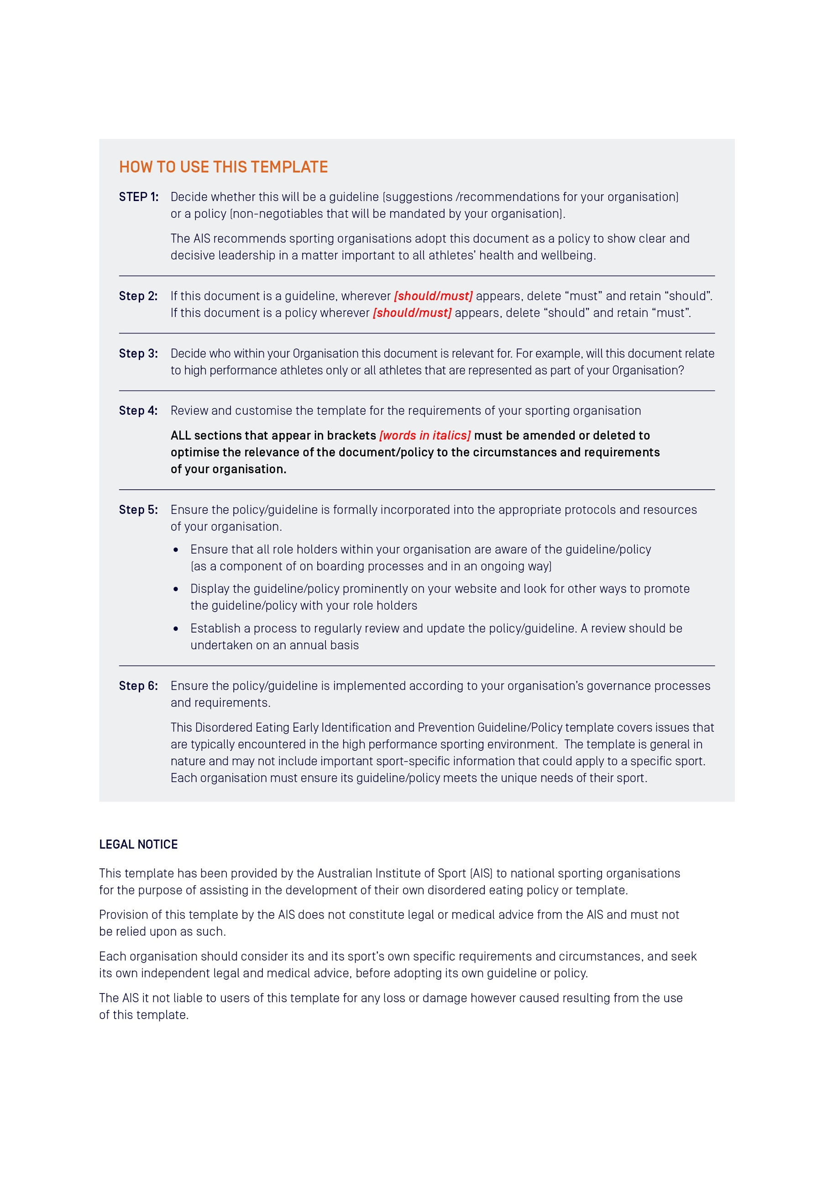

[Insert Organisation logo]

[Insert name of organisation]
Disordered Eating Early Identification
and Prevention Guideline/Policy*
[*This template refers to either a policy OR a guideline. Decide which one
you wish to use and keep this term consistent throughout the document]

Version [insert version number]
[insert date created/updated]

Contents

Preface
Review history
PART A – [Insert name of sporting organisation]’s Disordered Eating Early Identification and Prevention [Guideline/Policy]
- Introduction
- Purpose of this [guideline/policy] [decide which one and delete the other word]
- Who does this [guideline/policy] refer to?
- Organisational responsibilities
- Individual responsibilities
- Healthy sport system
- Management of disordered eating
  - Early identification
  - The Core Multidisciplinary Team (CMT)
  - Screening and diagnosis
  - Menstrual function in female athletes
  - Low energy availability and other signs of RED-S
- Prevention of disordered eating
  - Education
  - Optimised nutrition
  - Role of body composition
  - Body image
  - Use of language
  - Transition periods
- Other considerations
  - Eating Disorder treatment
  - Return to play
  - Working with minors
  - Para athletes
  - Making weight [delete if not appropriate to your sport]
  - Travel
- Breach of this [guideline/policy] [delete if not appropriate to your sport]
PART B – APPENDIX
- Definitions
- The AIS-NEDC Position Statement on Disordered Eating in High Performance Sport
- Body Composition Assessment | Considerations Relating to Disordered Eating
- RED-S Return to Play Clinical Assessment Tool

Preface
[Include a statement here from the President or CEO demonstrating a clear commitment at the highest level of your organisation to providing a safe sporting environment that works proactively for the prevention and early identification of disordered eating in athletes.
The Preface could state:
- That your organisation seeks to provide a safe sporting environment that promotes early identification of disordered eating to prevent eating disorders
- That all role holders within the organisation, including athletes, family members, coaches and performance support staff, have a responsibility to support a safe sporting environment
- That all role holders have the right to expect that the sporting environment in which they work is safe and supportive
- That the guideline/policy sets out actions that are implemented by the organisation to assist in providing this safe sporting environment]
Signature of CEO/President
Name of Sporting Organisation
Date

Review history of [insert name of organisation] Disordered Eating Early Identification and Prevention [Guideline/Policy]
Version | Date reviewed | Date endorsed | Content reviewed/purpose
One | Created [insert month/year] | [insert month/year endorsed] | [insert summary of amendments]
Two | [insert month/year reviewed] | [insert month/year endorsed] | [insert summary of amendments]
Three | [insert month/year reviewed] | [insert month/year endorsed] | [insert summary of amendments]

PART A: [Insert name of sporting organisation]’s Disordered Eating Early Identification and Prevention [Guideline/Policy]
- Introduction
Disordered eating (DE) and eating disorders (EDs) are serious and complicated issues that can affect the health and performance of ALL athletes across the high performance pathway, from junior to senior levels (see Appendix 1). [Insert name of sporting organisation] endorses the Australian Institute of Sport (AIS) and the National Eating Disorders Collaboration (NEDC) Position Statement on Disordered Eating in High Performance Sport (link here). This [guideline/policy] is to be read in conjunction with the Position Statement.
[Insert any details of your organisation here that are appropriate. This may include athlete inclusion/exclusion criteria of who this document refers to]
- Purpose of this [guideline/policy]
The [insert name of sporting organisation] Disordered Eating Early Identification and Prevention [Guideline/Policy] aims to assist our organisation to implement the practices required to provide a healthy sport system. The appropriate management, early identification and prevention of DE in our athletes is important in view of the significant ramifications on an athlete’s health (both mental and physical) and performance. We prioritise the health and wellbeing of our athletes and believe all role holders in our sporting system have a part to play.
This [guideline/policy] has been endorsed by [insert name of NSO Board or Committee] and has been [insert relevant information e.g. incorporated into our constitute document, rules, regulations or by-laws]. The [guideline/policy] starts on [insert date] and will operate until replaced.
The current [Guideline/Policy] and its attachments can be obtained from our website at: [Insert website address].
- Who does this [guideline/policy] apply to?
This [guideline/policy] applies to all role holders within [insert name of sporting organisation] including but not limited to [amend any that are not applicable]:
- Athletes
- Family and athlete support system
- CEO and Board members
- Executive and corporate support staff (for example marketing and sponsorship, communications, administration, reception/front of house, human resources)
- High Performance Director
- Coaches
- SSSM Manager, Performance Health Manager
- AW&E Manager/Advisor
- The DE Core Multidisciplinary Team (CMT) of psychologist, doctor and sports dietitian
- Sports Science Sports Medicine (SSSM) Practitioners (for example biomechanists, performance analysts, skill acquisition staff, soft tissue therapists, physiotherapists, strength and conditioning coaches, physiologists)
- [any other person to whom the guideline/policy applies]
[Insert name of sporting organisation] recommends that all State Institutes/Academies of Sport and Clubs adopt this [guideline/policy].

- Organisational responsibilities
[Insert name of sporting organisation] will:
- Adopt, implement and comply with this [guideline/policy].
- Ensure this [policy] is enforceable [delete this point if this is a guideline].
- Publish, distribute and promote this [guideline/policy].
- Promote and model appropriate standards of behaviour at all times.
- Deal with any complaints or concerns made under this [guideline/policy] in a timely manner.
- Deal with any breaches of this [guideline/policy] in an appropriate manner.
- Monitor and review this [guideline/policy] regularly.
- Individual responsibilities
Individuals bound by this [guideline/policy] must:
- Make themselves aware of the contents of this [guideline/policy].
- Comply with all relevant provisions of the [guideline/policy].
- Place the health and wellbeing of athletes above other considerations.
- Be accountable for their behaviour.
- Seek to engage in upskilling in the area as required.
- Healthy sport system
A healthy sport system is needed to support and nurture our athletes. At [Insert name of sporting organisation] we support the values and actions in this document. The environment and culture at [Insert name of sporting organisation] plays an important role in creating a healthy sport system. We recognise that how we treat all members of our Organisation is important, most importantly our athletes. The appropriate management, early identification and prevention of DE are the outcomes of a healthy sport system and will be discussed individually in more detail below.
- Management of disordered eating
  - Early identification
[Insert name of organisation] recognises that early identification of changes in an athlete’s thoughts around their body image and/or eating behaviours (along the spectrum of eating behaviour) is important in allowing a greater opportunity for reversal and recovery (see Appendix 1). Timely identification and intervention is ideal.
  - The Core Multidisciplinary Team (CMT)
[Insert name of organisation] recognises that the profession of the CMT provides a vital function in the early identification, assessment, diagnosis, treatment (where appropriate) and referral (as required) of DE and EDs. For the high performance program, [Insert name of organisation] [should/will]:
- Establish a CMT (if it doesn’t already exist) of doctor, sports dietitian and psychologist.
- Develop communication channels within the CMT and from the CMT to the broader support team.
Editing note: align content within this point with guideline/policy application for your Organisation.

  - Screening and diagnosis
[Insert name of organisation] recognises that the most useful tool in assessing the presence of DE or an ED in an individual athlete is a clinical interview with one or all members of the CMT.
  - Menstrual function in female athletes
[Insert name of organisation] recognises the importance of normal menstrual function in our female athletes. [Insert name of organisation] encourages athletes to monitor their menstrual function from a health perspective. Any menstrual irregularities [should/must] be investigated with a doctor.
  - Low energy availability and other signs of Relative Energy Deficiency in Sport (RED-S)
[Insert name of organisation], recognises that DE can occur in isolation or in combination with low energy availability (LEA), and their interaction and associated forms of presentation [should/must] be properly identified. Athletes [should/must] be referred for appropriate professional assessment (or to the CMT where this exists within an organisation and is available to the athlete) and support in the circumstances below:
- Any athlete with known or suspected DE;
- Any athlete with known or suspected LEA;
- Any athlete who is diagnosed with a bone stress injury and/or identified with menstrual dysfunction;
- Any athlete with recurrent injuries and/or illnesses.
Athletes who are identified in these categories [should/must] be provided with ongoing monitoring, support and
regular review.
- Prevention of disordered eating
[Insert name of organisation] recognises the ideal of preventing DE and EDs within the high performance sporting environment via education, support for optimised nutrition and positive body image in athletes, and appropriate assessment of body composition.
  - Education
At [Insert name of organisation] we support the education of our coaches, performance support staff, athletes, and athlete support system to assist in early identification and prevention of disordered eating.
  - Optimised nutrition
[Insert name of organisation] recognises that athletes [should/must] be able to access nutrition support that meets the criteria for optimised nutrition; a harmony between health and performance underpinned by concepts that are safe, supported, purposeful and individualised. An appropriately qualified and experienced Sports Dietitian [should/must] provide the nutritional education to athletes.
Editing note: align content within this point with guideline/policy application for your Organisation.
  - Role of body composition
Where body composition plays a role in sports performance, this role can be understood and integrated into an appropriate personalised plan for each athlete. [Insert name of organisation] recognises that the assessment of body composition is a common part of athlete assessment, and needs to be appropriately implemented to safeguard the athlete’s health and well-being. Appropriate implementation includes a range of considerations including but not limited to the need for assessment, selection of assessment technique/s, implementation of protocols and dissemination of results.
See [Insert name of sporting organisation link here or link to AIS body composition considerations] for further details. These considerations [should/must] be followed whenever body composition assessment techniques are utilised.
  - Body image
[Insert name of organisation] recognises that a positive body image is one of the protective factors that enable an athlete to be more resilient to developing DE or an ED. Appropriate support [should/must] be provided to athletes to encourage a positive body image, using activities targeted at groups and individuals. Positive body image in athletes is promoted through education and support for all roles holders at [Insert name of sporting organisation], not just in our athletes.
  - Use of language
Positive language [should/must] be used when speaking with and about athletes and their bodies. Athletes, coaches and performance support staff [should/must] receive education around such language. [Insert name of organisation] believes all bodies deserve to be treated with respect, no matter their size, shape, composition, colour or ability. Before any athlete is asked to change their body (in either size or composition), the CMT [should/must] be consulted and involved in the decision making and communication process.
  - Transition periods
[Insert name of organisation] recognises that there are a number of transition periods in an athlete’s life that may place them at an increased risk of DE including, but not limited to:
- Early start of sport specific training;
- Making a senior team at a young age;
- Retirement (forced or voluntary);
- Non-selection or de-selection;
- Injury, illness, surgery, time away from sport and training;
- Changes in weight and/or body shape following injury or illness;
- Major life transitions e.g. moving away from home, moving between schools, moving overseas;
- Preparation for and competing in a benchmark event (e.g. in the selection process, the period prior to the event, during and after the event).
At [Insert name of sporting organisation] we [should/must] identify states of elevated risk and apply appropriate support around the athlete at these times, with activities involving the coach, support staff or the CMT directly.
- Other considerations
  - Eating Disorder treatment
Treatment of an athlete with a diagnosed eating disorder may be most appropriate through a clinical eating disorder treatment capacity, independent of the [Insert name of organisation] sporting environment. There are times, however, where the [Insert name of organisation] CMT may be involved in an athlete’s ED treatment. [Insert name of organisation] [should/must] support and enable our CMT to undertake this role.
  - Return to play
Whilst there are no specific DE or ED return to play guidelines, for [Insert name of organisation] athletes, the CMT [should/must] work together and with any external ED treatment team to ensure the return to play of an athlete is appropriate for their individual case. An athlete identified with DE may need training modifications or exclusions to minimise the risk of potential injury and/or illness. [Insert name of organisation] CMT [should/must] work together with coaches and other performance team members to ensure an individual approach is taken to the athlete’s training regime.
See Appendix 4 for RED-S Clinical Assessment Tool (CAT) as an example of an exclusion and return to play guideline.
  - Working with minors
[Insert name of organisation] recognises working with minors requires appropriate care and consideration for this population. See [Insert name of organisation’s Child Safe Sport document here] for more details.
Whilst DE can occur at any age, we understand that adolescence is a formative time in the development of an athlete’s body image and eating behaviour. [Insert name of organisation] athletes in this age group [should/must] be provided with appropriate education and support to assist in the development of optimal body image and eating behaviours.
A registered medical professional is responsible for determining if and when and under-age athlete’s family will be informed of DE or an ED. Whilst patient confidently is important, there are times when the athlete’s family will need to be informed.
  - Para athletes
[Insert name of organisation] recognises that para athletes have unique considerations around body image and eating behaviour. The CMT [should/must] work individually with each para athlete and their coach and performance support staff to ensure that the needs of the athlete are met.
  - Making weight [delete section if not appropriate to your sport]
[Insert name of organisation] recognises that “making weight” for weight categories/targets increases the risk of body image dissatisfaction, DE and EDs in athletes. Athletes [should/must] be provided with appropriate support including regular and ongoing access to the CMT.
  - Travel
[Insert name of organisation] recognises its role in creating a safe environment during travel just as it does in our athlete’s daily training environment (DTE).
- An athlete known to have an ED [should/must] have travel clearance from the CMT within their relevant treatment team.
- If an athlete is identified as having a potential ED while travelling, the [Insert name of organisation] doctor in charge (whether they are travelling with the team or not) may send the athlete home if it is in their best interests, physically and/or mentally.
- Where an athlete’s DTE is overseas, the CMT of [Insert name of organisation] and the CMT in the athlete’s DTE [should/must] work together to ensure due care and appropriate access to the required medical, nutritional and psychological support.
- Breach of this [guideline/policy]
[delete section if not appropriate to your sport]
On occasions that this [guideline/policy] is not adhered to, appropriate action will be taken in accordance with the procedures outlined in [Insert name of organisation]’s [insert name of applicable disciplinary regulations document].

Appendix 1: Definitions
Body image – the perception that an athlete has about their physical self and the thoughts and feelings that result from that perception.
Positive body image – occurs when an athlete is able to accept, appreciate and respect their body. A positive body image is one of the protective factors that can make an athlete more resilient to developing an eating disorder.
Body image dissatisfaction – occurs when an athlete has negative thoughts and feelings about their body, and can result in a fixation on trying to change their body. This can lead to unhealthy food and exercise practices and increase the risk of developing an eating disorder.
Core-Multidisciplinary Team (CMT) – A team of professional practitioners (doctors, sports dietitians, psychologists) who collaborate in the management of disordered eating cases. In the Australian case this would be a Sports Doctor or General Practitioner, an Accredited Sports Dietitian and a Registered Psychologist or Endorsed Sport Psychologist.
Energy availability (EA) – the amount of energy that is available to support the body’s activities for health and function once the energy commitment to exercise has been subtracted from dietary energy intake. Energy availability = (Energy intake – Energy cost of exercise)/Kg fat free mass
Low energy availability (LEA) - occurs when there is a mismatch between energy intake and exercise load, leaving insufficient energy to cover the body’s other needs. It may arise from inadequate energy intake, increased expenditure from exercise, or a combination of both, and is either advertent or inadvertent
Relative energy deficiency in sport (RED-S) – the syndrome of impaired physiological function including, but not limited to, metabolic rate, menstrual function, bone health, immunity, protein synthesis and cardiovascular health that arises from low energy availability.
Spectrum of eating behaviour – in the high performance athlete, from optimised nutrition to disordered eating to an eating disorder. All athletes sit on this spectrum and individuals move back and forth along the spectrum at different stages of their career, including within different phases of a training cycle.
Optimised nutrition – involves a safe, supported, purposeful and individualised approach. It promotes healthy body image and thoughts about food, and is adaptable to the specific and changing demands of an athlete’s sport.
Disordered eating (DE) – may range from what is commonly perceived as normal dieting to reflecting some of the same behaviour as those with eating disorders, but at a lesser frequency or lower level of severity. DE can occur in any athlete, in any sport, at any time, crossing boundaries of gender, culture, age, body size, culture, socio-economic background, athletic calibre and ability.
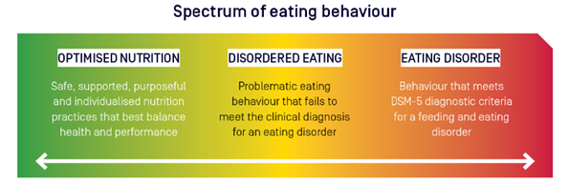
Eating disorder (ED) – A serious but treatable mental illness with physical effects that can affect any athlete. Feeding and eating-related disorders are defined by specific criteria published in the diagnostic and statistical manual of mental disorders (DSM-5) which include problematic eating behaviours, distorted beliefs, preoccupation with food, eating and body image, and result in significant distress and impairment to daily functioning (e.g. sport, school/work, social relationships).

Appendix 2: The AIS-NEDC position statement on disordered eating in high performance sport

Appendix 3: AIS or Organisations own Body Composition Assessment | Considerations Relating to Disordered Eating

Appendix 4: RED-S Return to Play Clinical Assessment Tool

