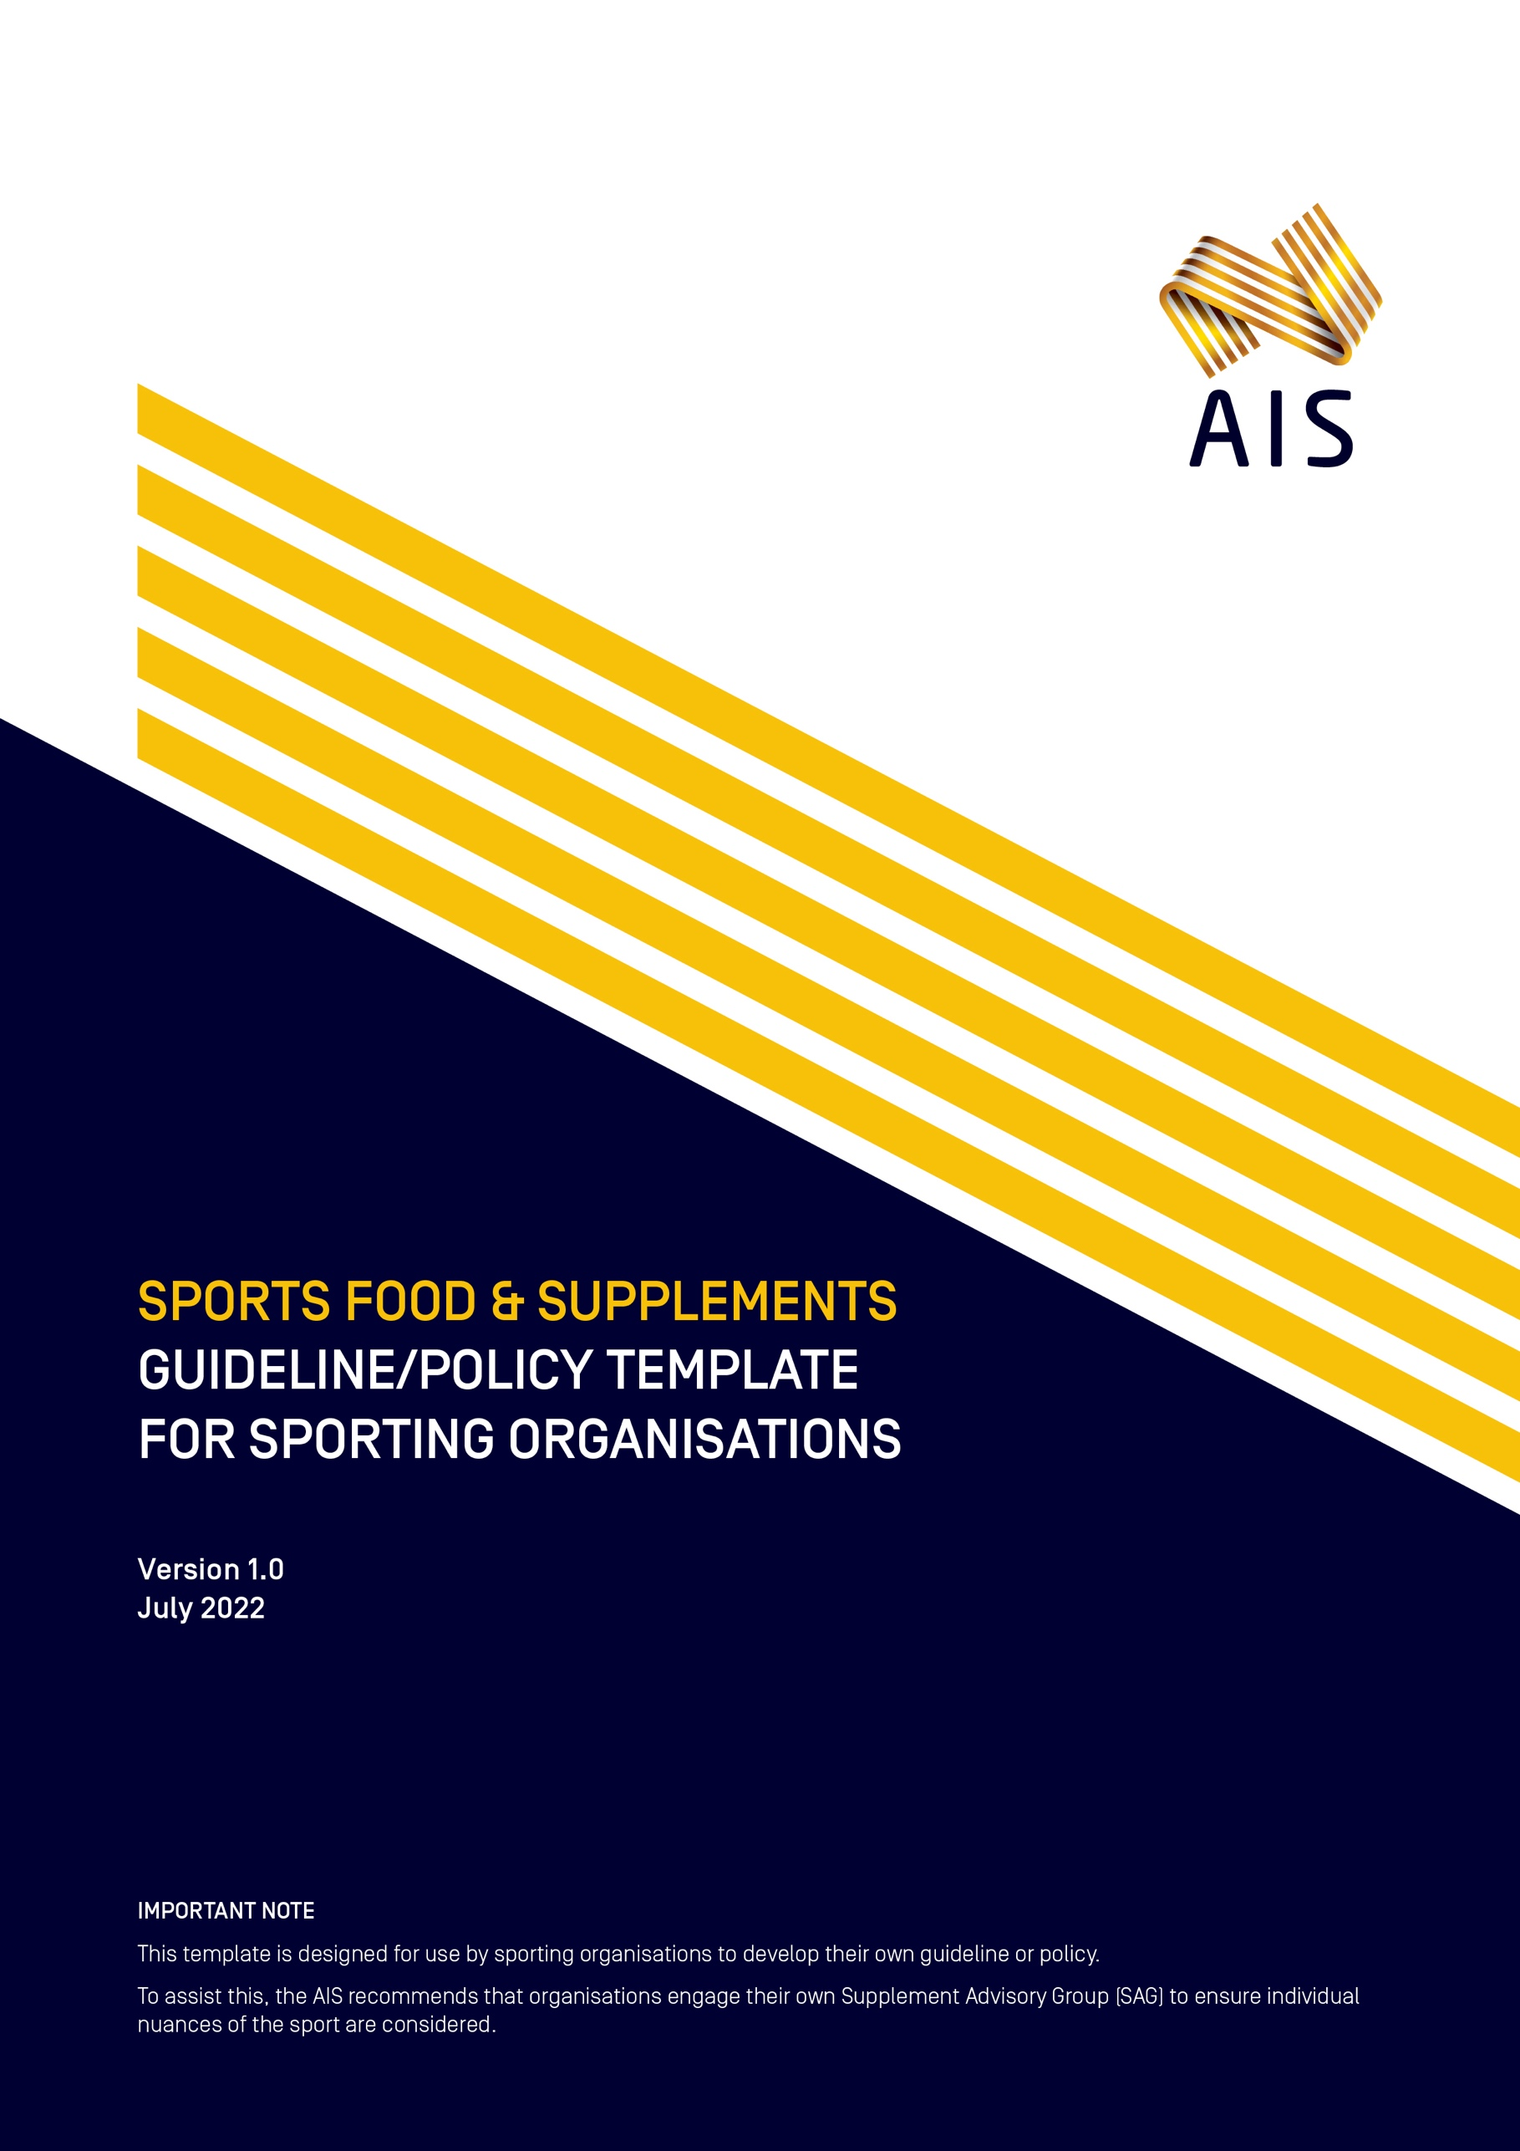

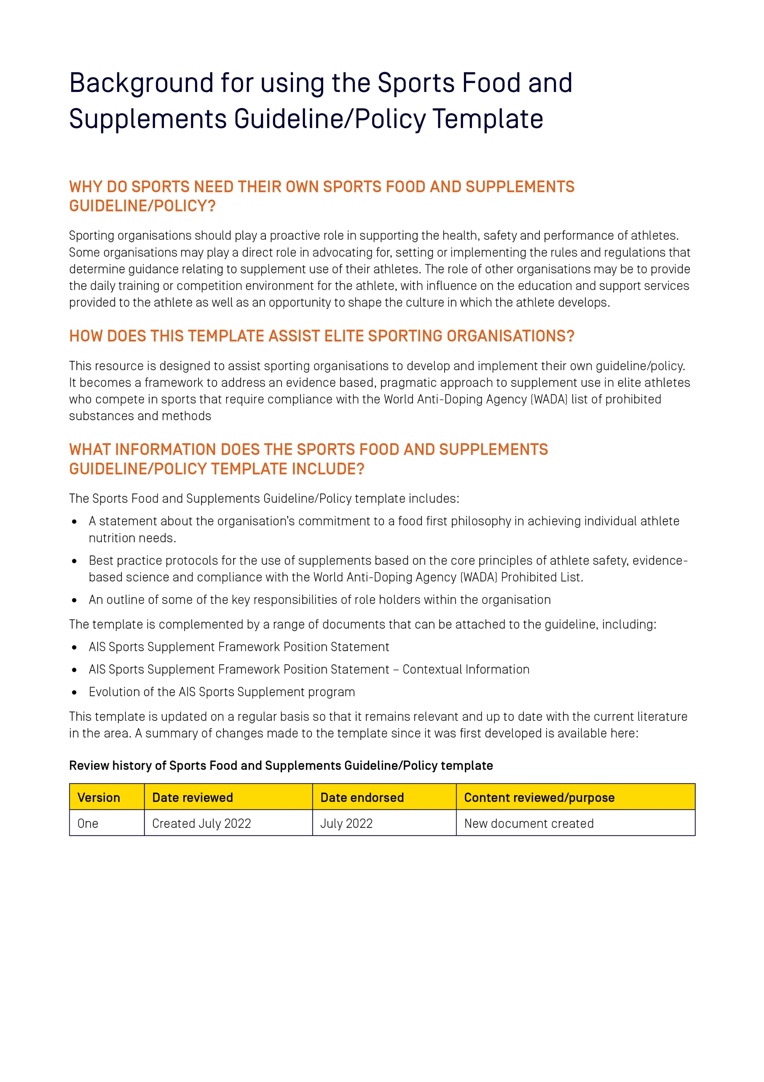

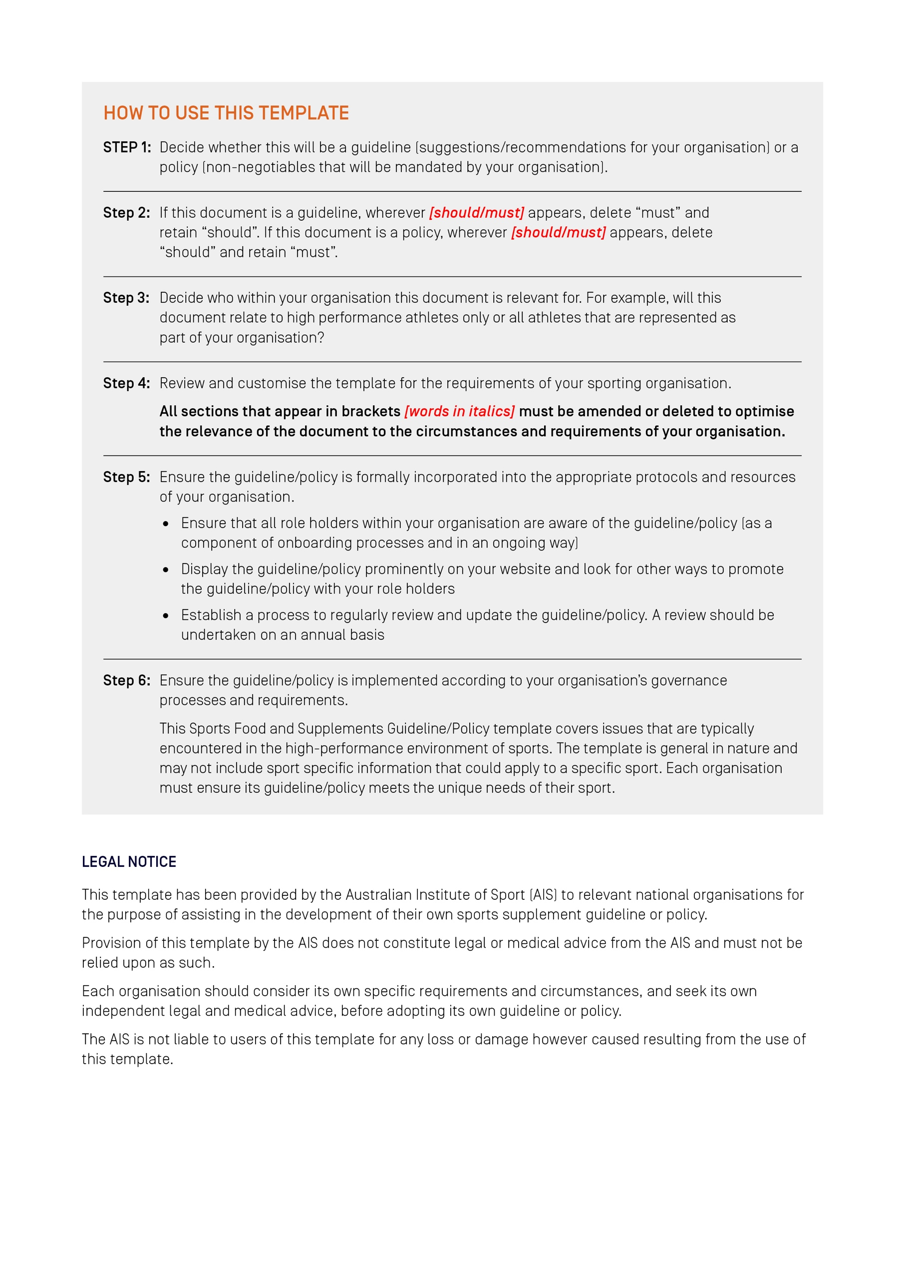

[Insert Organisation logo]

[Insert name of organisation]
Sports Food and Supplements
Guideline/Policy*
[*This template refers to either a policy OR a guideline. Decide which one
you wish to use and keep this term consistent throughout the document]

Version [insert version number]
[insert date created/updated]
Table of Contents
Preface 6
[Insert name of sporting organisation]’s Sports Food and Supplements [Guideline/Policy] 7
Introduction 7
Purpose of this document 7
Who does this [guideline/policy] apply to? 8
Interaction with other policies 8
Organisational responsibilities 9
Supplement Advisory Group 9
Individual responsibilities 10
1. Supplements – what can be used? 11
Group C Supplements 12
Group D Supplements 12
2. Foods fortified with ‘supplemental’ ingredients 12
3. Junior athletes 13
Breach of this [guideline/policy] 13
Further information 14
Definitions 14
Appendix 1 – Athlete Responsibilities 15
Appendix 2 – Performance Support Staff Responsibilities 16
Appendix 3 – Sport Participant Guidance 17
General advice 17

Preface
- [Include a statement here from the President or CEO demonstrating a clear commitment at the highest level of your organisation to establishing a best practice approach for the use of supplements, with a focus on athlete safety, and evidence-based uses given the risk of supplements may contain substances included on the World Anti-Doping Agency’s (WADA) List of Prohibited Substances and Methods.
The Preface could state:
- That your organisation seeks to provide a safe sporting environment that promotes a pragmatic, evidence-based approach to supplement use that discourages use of high-risk supplementation practices
- That all role holders within the organisation, including athletes, family members, coaches and performance support staff, have a responsibility to support and comply with the guidelines

Signature of CEO/President
Name of Sporting Organisation
Date

Review history of [insert name of organisation] Sports Food and Supplements [Guideline/Policy]
Version | Date reviewed | Date endorsed | Content reviewed/purpose
One | Created [insert month/year] | [insert month/year endorsed] | [insert summary of amendments]
Two | [insert month/year reviewed] | [insert month/year endorsed] | [insert summary of amendments]
Three | [insert month/year reviewed] | [insert month/year endorsed] | [insert summary of amendments]

[Insert name of sporting organisation]’s Sports Food and Supplements [Guideline/Policy]

Introduction
[insert name of sporting organisation] acknowledges the use of supplements in sport and is committed to establishing best practice protocols for supplement use consideration based on the core principles of athlete safety, evidence-based science and compliance with the World Anti-Doping Agency (WADA) Prohibited List. [insert name of sporting organisation] approves of the appropriate use of supplements in accordance with this [guideline/policy] to support a nutritional program and promotes the ‘food first’ message, which is that a person is more likely to benefit from a health and performance focused, outcome driven meal plan, which should be established with the assistance of an accredited sports dietitian (ASD).

There is no expectation or requirement that any individual associated with [insert name of sporting organisation] must use supplements. Furthermore, limitations to the regulation of the supplement industry mean that marketing hype may exaggerate the benefits of supplements, and there is currently no guarantee that any particular supplement is totally free from substances on the WADA Prohibited List. If an athlete uses supplements in an unregulated manner, they may risk committing a ‘doping’ offence, compromise their health or performance, waste time and money on products that have no measurable benefit on their performance; and/or set a poor example for other members of the community.

Each athlete is solely responsible for any substances on the WADA Prohibited List (or traces of them) found to be present in their body and for their possession, use, attempted use, trafficking or attempted trafficking of the substances or methods on the WADA Prohibited List. If an athlete wishes to use supplements, the best way to mitigate the risks associated with them is to comply with this [guideline/policy]. This [guideline/policy] should not be considered as a substitute for any athlete seeking the professional advice of an ASD or doctor, who can provide that athlete with the latest information on the risks and benefits of using a particular supplement and if applicable, recommend to them an appropriate protocol for using that supplement.

[Insert name of sporting organisation] endorses the Australian Institute of Sport (AIS) Position Statement on Supplements and Sports Foods in High Performance Sport, which provides expert classification of supplements and is subject to ongoing research, continual review and change, in a form that is most relevant to our organisation and athletes.

As part of mitigating risks associated with supplement use, [insert name of sporting organisation] has implemented certain mandatory third-party batch testing obligations in accordance with the terms of this [guideline/policy].

[Insert any details of your organisation here that are appropriate.]

Purpose of this document
The [insert name of sporting organisation] Sports Food and Supplements [guideline/policy] is based on the principle that athletes are best served by eating a well-considered, performance-focused diet to support training and competition, as well as promoting the long-term health of the athlete. However, this [guideline/policy] acknowledges the small, but potentially valuable role that supplements may play, as an addition to a “food first” nutrition plan, in meeting the special demands of training and competition, which should be established with the assistance of an ASD. This [guideline/policy] has been developed by [insert name of sporting organisation] with the objective of:
- Providing athletes (and others where relevant) with access to expert information on nutrition and supplements and allowing them to make informed decisions on supplement use
- Minimising the risk of an anti-doping rule violation (ADRV), or the compromise of athlete health and/or performance, resulting from supplement use Providing direction on appropriate governance of the [guideline/policy], including appropriate membership of the body established to oversee guidance and regulation of supplement use
- Establishing and advocating a minimum standard of qualification and accreditation for those persons responsible for supplement advice (± provision)
- Providing leadership for lower-level participation athletes, and non-contracted junior, developing and emerging athletes, to help them to make appropriate decisions regarding the safe and appropriate use of supplements.

We prioritise the health and wellbeing of our athletes and believe all role holders in our sporting system have a part to play. We aim to assist our organisation to implement an evidence based, safe and legal approach to supplement use as part of a broader performance nutrition strategy.
This [guideline/policy] has been endorsed by [insert name of NSO Board or Committee] and has been [insert relevant information e.g. incorporated into our constitute document, rules, regulations or by-laws]. The [guideline/policy] starts on [insert date] and will operate until replaced.
The current [guideline/policy] and its attachments can be obtained from our website at: [Insert website address].

Who does this [guideline/policy] apply to?
This [guideline/policy] applies to all role holders within [insert name of sporting organisation] including but not limited to [amend any that are not applicable]:
- Athletes (defined here as any participant who falls under any of Sport Integrity Australia Testing Pools i.e., Registered, National and/ or Domestic), plus all other employees of [insert name of sporting organisation], including…
  - [CEO and Board members]
  - [Executive and corporate support staff (for example marketing and sponsorship, communications, administration, reception/front of house, human resources)]
  - [High Performance Director]
  - [Coaches]
  - [Performance Support managers and practitioners]
  - [any other Athlete Support Personnel to whom the [guideline/policy] applies]
- For any other athletes, the purpose of this [guideline/policy] is to provide guidance and education in relation to best practice supplement use
[Insert name of sporting organisation] recommends that all State Institutes/Academies of Sport and Clubs adopt this [guideline/policy].

Interaction with other policies
In the event of an inconsistency with the Anti-Doping Policy or the National Integrity Framework Improper Use of Drugs and Medicine policy, the Anti-Doping Policy or the National Integrity Framework Improper Use of Drugs and Medicine policy takes precedence as relevant.

Organisational responsibilities
[Insert name of sporting organisation] will:
1.1 adopt, implement and comply with this [guideline/policy]
1.2 ensure this [guideline/policy] is made available to those bound by this [guideline/policy] once it is in place
1.3 ensure that each athlete and employee receives and attends appropriate education programs in relation to this [guideline/policy], including prior to the [guideline/policy] becoming effective
1.4 ensure that each athlete and employee is notified of any change to this [guideline/policy]
1.5 ensure that the information recorded on the centrally-documented system pursuant to this [guideline/policy], is subject to strict and appropriate access controls in accordance with Australian privacy legislation
1.6 discharge the organisations obligations under this [guideline/policy] in a discreet and confidential manner
1.7 develop and implement appropriate education programs and initiatives in relation to the key messages of this [guideline/policy]
1.8 ensure that there are opportunities for key performance support practitioners/ managers to have their existing practices and procedures peer reviewed
1.9 consider and review the compliance of athletes and employees with this [guideline/policy] and, if considered appropriate, conduct a compliance audit [delete this point if this is a guideline]
1.10 remain committed to ongoing research and expert advice from recognised regulatory bodies in relation to sports nutrition and supplement use
1.11 establish and maintain a Supplement Advisory Group (SAG) to oversee governance of the [guideline/policy]

Supplement Advisory Group
[Insert name of sporting organisation] will establish and maintain a SAG for the purposes of:
1.12 considering requests or other evidence relating to classifying or reclassifying a supplement and if appropriate, consulting with the AIS sports supplement program in relation to the classification of that Supplement (Supplement Reclassification Form);
1.13 frequency of SAG meetings should be three months at minimum;
1.14 considering the suitability of batch testing providers;
1.15 determining whether prospective sponsorship or other agreements comply with this [guideline/policy]
1.16 reviewing and monitoring the information recorded on the centrally-documented system pursuant to this [guideline/policy]
1.17 providing advice and recommendations on supplement use, including the population of Table 1, which addresses issues on specific supplement groups (and specific supplements, where appropriate) and their required approval prior to ingestion, requirement for third-party batch testing, plus supplements provided to athletes and by whom;
1.18 reviewing the effectiveness of this [guideline/policy]; and
1.19 reporting to [Insert name of sporting organisation] on an annual basis in relation to the operation of, and the information provided under, this [guideline/policy].

[Insert name of sporting organisation] will have the sole discretion to appoint and remove members of the SAG and will endeavour at all times to have a member of the SAG that is external to [Insert name of sporting organisation]. The members of the SAG should include as a minimum:
  - the [Insert name of sporting organisation] Chief Medical Officer
  - the [Insert name of sporting organisation] Performance Nutrition Lead
  - a representative of the [Insert name of sporting organisation] Integrity Unit
  - an athlete representative of the [Insert name of sporting organisation]
  - a representative from the AIS Sports Supplement Program or a suitably qualified independent person.
  - Other members, as deemed appropriate for [Insert name of sporting organisation]
Where [Insert name of sporting organisation] does not have the resources to accommodate such membership due to resource constraints, A Supplement Policy Officer (SPO) should be appointed, with the support of at least 1 member of the AIS Supplement Framework, plus an athlete representative.

The SAG will be governed according to the following principles:
- the SAG will discharge its obligations under this [guideline/policy] in a discreet and confidential manner
- if all the members of the SAG have received reasonable notice of a meeting and a quorum is present, the meeting is competent to exercise all or any of the authorities, powers or discretions vested in or exercisable by the SAG
- the SAG will hold [quarterly/ biannually/ yearly] meetings to discuss any issues arising out of this [guideline/policy]
- a quorum of the SAG is three (3) and must include the Chair
- questions arising at a meeting of the SAG are to be decided by a majority of votes cast and must include the vote of the Chair (appointed from membership group) and any such decision is for all purposes a determination of the SAG and must be minuted
- a written resolution may be passed if all of the members of the SAG, other than a member on leave from the SAG or otherwise not entitled to vote, have had a reasonable opportunity to consider a proposed resolution, and if the members who assent in writing to the proposed resolution (including by electronic means) would have constituted a quorum at a meeting of the SAG, then that resolution is taken as having been passed by the SAG; and
- in the case of an equality of votes upon any proposed resolution, the Chair will have the casting vote.

The SAG may request that mandatory third-party batch testing of any supplement be conducted before its use by an athlete. Where the SAG notifies the ASD or athlete, the athlete must not use the supplement until receipt of written notice from SAG (or its nominee) that SAG is satisfied with the result of the third-party batch testing.

Individual responsibilities
Individuals bound by this [guideline/policy] must:
1.20 comply with this [guideline/policy] and only obtain and use any supplement in accordance with the conditions set out in this [guideline/policy]
1.21 not enter into any sponsorship or other arrangement in relation to supplements without prior approval from [Insert name of sporting organisation] and an athlete will not enter or seek to enter into any such arrangement that will cause them to not comply with this [guideline/policy]
1.22 promptly report to the SAG, any person’s conduct (including their own conduct or an approach to engage in conduct) that they know or reasonably suspect may be a breach of this [guideline/policy]
1.23 disclose to the SAG, if requested, all details in their knowledge relating to information that indicates their apparent or suspected non-compliance with this [guideline/policy]
1.24 consent to the provision and recording of information about them in accordance with this [guideline/policy]
1.25 use their influence to support and reinforce the education messages regarding supplements that are promoted by [Insert name of sporting organisation], including in this [guideline/policy]
1.26 make themselves available for, and actively engage in, education programs in relation to this [guideline/policy]
  - stay informed of any changes to this [guideline/policy]

1. Supplements – what can be used?
In this [guideline/policy], Supplements are classified into six groups (Group A – Sports Foods, Medical Supplements and Performance Supplements, Group B, Group C and Group D) according to their effectiveness and safety, as set out in the AIS Sports Supplement Framework (adapted for [Insert name of sporting organisation])

An athlete may use a Group A or B supplement on the following conditions:
- they have received permission to do so and advice in relation to using that supplement from their doctor/ ASD
- they use it in support of a nutrition program that emphasises appropriate timing, quantity and choice of meals and snacks focusing on whole foods, developed by their ASD
- they are educated about the appropriate use of the supplement and its place in an appropriate sports nutrition program; and
- they have carefully considered the risk of any inadvertent Doping Offence as a result of using the supplement.
- adequate clinical and performance monitoring is available to assess individual athlete tolerance and potential benefits (Group B supplements)

If an athlete wishes to use a supplement, they [will/will not] first require permission from ASD, in accordance with guidance specified in Table 1.
Table 1 – Examples of categorized supplements and the authorisation for sport practitioners, ASD and/or Doctors to provide to athletes.
Group | ASD/ Doctor Approval¹ | Exemption from ASD/ Doctor approval² | 3rd Party Batch Tested | Exemption³ from 3rd party Batch Testing | Specific products provided to athletes | Staff approved to provide to athletes
A – Sports Foods | [YES/NO] | e.g. Sports drinks, confectionary and bars, electrolyte supplements | [YES/NO] | e.g. Sports drinks, confectionary and bars, electrolyte supplements | e.g. Gatorade | Provided by any performance support personnel
A – Medical | [YES/NO] | NIL | [YES/NO] | e.g. Therapeutic Goods Administration (TGA) Registered Medicine (AUST-R) | e.g. Medical Maltofer | Provided by Doctor and/or ASD
A – Performance | [YES/NO] |  | [YES/NO] | e.g. Therapeutic Goods Administration (TGA) Registered Medicine (AUST-R) | e.g. Performance Musashi creatine monohydrate | Provided by an ASD
B | [YES/NO] |  | [YES/NO] |  | NIL | NIL
¹This identifies if ASD and/or doctor approval is required prior to athletes consuming specific supplements. Irrespective, athletes are strongly encouraged to seek the expert advice of their ASD and/ or doctor prior to the use of any supplement, to assist the athlete in better understanding the potential value of the supplement in their specific circumstances and goals, as well as giving consideration to their current dietary intake and training. For some supplements, that guidance is considered mandatory and ASD and/ or doctor approval prior to use.
²Some supplements may be exempt from requiring ASD and/ or doctor approval prior to use. This is most likely within the sports food group., but is the responsibility of the SAG.
³Third party batch tested Group A and B supplements should only be sourced, except for those group A supplements exempted by the SAG, and/ or Group A – Medical supplements that are Registered Medicines.

Group C Supplements
Generally, all athletes are prohibited from using any Group C supplement. However, there may be some limited circumstances in which an athlete will receive permission to use a Group C supplement and its use will be adequately monitored by a doctor/ ASD. This permission must be in writing from an athletes ASD and must be approved by a doctor. All Group C supplements must undergo third-party batch testing by a provider deemed suitable by SAG.

If an athlete believes that their circumstances are exceptional and they wish to use a Group C Supplement, they must first:
- receive permission from their ASD to use the supplement and this permission must have been approved by their Doctor, only source that supplement from their ASD and only use that supplement as directed by their ASD; or
- receive written permission from their ASD to source that supplement from a third-party provider and this permission must have been approved by their doctor, and only source and use that supplement as directed by their ASD.
- ensure the supplement has undergone third-party batch testing by a provider deemed suitable by SAG.

Group D Supplements
All athletes are prohibited from using any Group D Supplement. Group D Supplements are banned by WADA or are at high risk of being contaminated with substances that could lead to a positive drug test or are at high risk of compromising am athlete’s health and safety.

2. Foods fortified with ‘supplemental’ ingredients
The food industry is increasingly fortifying manufactured foods with ingredients commonly considered supplements within the general community, presumably to enhance the nutritional value of the food, facilitate adept marketing, leveraging on consumer interest in supplements. This may include vitamins & minerals, but also isolated proteins and even botanicals. Protein fortified foods (PFFs) were the subject of a recent detailed investigation, which aimed to determine the contamination risk of these foods containing WADA prohibited substances. While PFFs commercially manufactured within Australia under the Food Standards Australia New Zealand (FSANZ) code were identified to present no additional risk of containing WADA prohibited substances than other processed foods with mixed ingredients, this is specific to foods fortified with isolated protein ingredients. The fortification of foods with other ‘supplemental’ ingredients other than protein is likely to continue to evolve and the risk profile will likely depend on the specific ‘supplemental’ ingredient, and the manufacturer. For example, while PFFs manufactured under Australian food safety standards, and in accordance with good manufacturing practices by large food companies provide no additional risk to other manufactured foods, this is not the case for PFFs sold at cafés as the risk is largely unknown. As such, [Insert name of organisation] SAG [should/must] provide guidance to the organisation on the risk profile associated with foods fortified with specific ‘supplemental’ ingredients.
The manufacturing of food grade hemp protein is similar to dairy and plant-based proteins and therefore risk of contamination with WADA prohibited substances is likely similar. However, the isolated protein ingredient source of hemp protein may contain traces of the WADA prohibited substance Tetrahydrocannabinol (THC) and other cannabinoids. This is inherent to the ingredient and not introduced via contamination during the manufacturing of the protein. Hemp protein has a risk of containing traces of THC and other cannabinoids inherent to the raw plant source. Currently, there is insufficient scientific evidence regarding the contamination profile of hemp protein and as such hemp protein containing PFF’s and supplements should be avoided by athletes.

3. Junior athletes
In view of the negative consequences of inappropriate supplement practices, [Insert name of organisation] promote the general principle that junior athletes (<18 years of age) [should/must] not use sports supplements. [Insert name of sporting organisation] endorses the position of Sports Dietitians Australia that specifies ‘nutrient needs should be met by core foods rather than supplements, as the recommendation of dietary supplements to developing athletes over-emphasizes their ability to manipulate performance in comparison with other training and dietary strategies’.

Breach of this [guideline/policy]
[delete section if not appropriate to your sport]
On occasions that this [guideline/policy] is not adhered to, appropriate action will be taken in accordance with the procedures outlined in [Insert name of organisation]’s [insert name of applicable disciplinary regulations document].
A person commits a breach of this [guideline/policy] when any of the following occurs:
- An athlete fails to record their supplement use on the Athlete Management System or an equivalent system within the required timeframe which is generally within 24 hours, unless otherwise specified by the SAG
- An Athlete fails to obtain the prior written approval before entering into an arrangement regarding supplement endorsement or use
- A person provides or supplies supplements without authority
- There is use of supplements that are not approved by a doctor or ASD, that are not otherwise exempted from ASD or doctor pre-approval
- A person refuses or unreasonably fails to comply with a reasonable direction of [Insert name of organisation] made under this [guideline/policy].
- A person does or fails to do anything that is reasonably deemed by [Insert name of organisation] to be a breach of this [guideline/policy].

Sanctions [May not be necessary if the NSO already has a disciplinary regulations document]
Any [Insert name of organisation] athlete or athlete support person (including employees, volunteers or contractors) who is found to have breached this [guideline/policy] may face disciplinary action. [Insert name of organisation] may impose sanctions such as the following:
- A warning (generally accompanied by the completion of education)
- Suspension from competition for a specified period
- Suspension from access to athletes for a specified period
- Banning from participation in NSO-related competition, training or events (including selection in representative teams)
- Suspension from [Insert name of organisation] organised training; and/or
- Suspension or termination of contract or financial support.

NOTE: All [Insert name of organisation] athletes and Athlete Support Personnel are bound by all applicable [Insert name of organisation] policies and procedures, including the following:
- World Anti-Doping Code
- [Insert name of organisation] Anti-Doping Policy
- [Insert name of organisation] Code of Conduct
- [Insert name of organisation] Supplements/No Needles Policy
- Illicit Drugs in Sport Policy

Further information
https://www.ais.gov.au/nutrition/supplements
https://www.sportintegrity.gov.au/what-we-do/anti-doping/supplements-sport
https://www.sportsdietitians.com.au/

Definitions
SAG: Supplement Advisor Group
WADA: World-Anti Doping Agency
ASD: Accredited Sports Dietitian
AIS: Australian Institute of Sport
ADRV: Anti-Doping Rule Violation
NSO: National Sporting Organisation
SAG: Supplement Advisory Group
CMO: Chief Medical Officer
SPO: Supplement Policy Officer
TGA: Therapeutic Goods Administration
PFF: Protein Fortified Foods
FSANZ: Food Standards Australia New Zealand

Appendix 1 – Athlete Responsibilities
[Insert name of organisation] Sports Food and Supplements [guideline/policy] - Summary for Athletes
Some supplements may play a role in supporting health and/ or performance outcomes in specific circumstances, although this varies between individuals. However, there is no expectation or requirement for you to use Supplements and you are more likely to benefit from a ‘food first’ approach to achieving your unique health and performance nutrition needs, established with the assistance of your Sports Dietitian.

[Insert name of organisation] Sports Food and Supplements [guideline/policy] has been introduced because there are limitations to the regulation of the supplement industry and by taking Supplements, you may:
- risk committing a doping offence
- compromise your health or performance;
- waste time and money on products that have no benefit to your performance; and
- set a poor example for the community.

Athletes are reminded that they are responsible for all substances that enter their body under the ‘strict liability’ rules of the World Anti-Doping Code. Some supplements are riskier than others. The Sport Integrity Australia (SIA) App is a useful resource to help mitigate the risk of inadvertent doping by helping to identify supplements that have been batch-tested. The SIA App provides a list of more than 11,000 batch-tested products. We recommend that all athletes consult the educational resources of SIA regarding the risks associated with supplements and sports foods. While batch-tested products have the lowest risk of a product containing prohibited substances, they cannot offer you a guarantee that they are not contaminated www.sportintegrity.gov.au/what-we-do/supplements-sport

Sports Foods
You [do/do not] generally need permission to use Sports Foods (such as sports drinks, sports bars and electrolyte supplements). If you choose to consume Sports Foods, you should do so in support of a ‘food first’ program that emphasises whole foods and appropriate timing, quantity and choice of meals and snacks.

Other Supplements
For all other Supplements, before you use them you must:
- receive them from your doctor/ sports dietitian or receive permission from your doctor/ sports dietitian to source them elsewhere;
- use the supplement as directed by your doctor/ sports dietitian to support an appropriate sports nutrition program;
- carefully consider the risk of an inadvertent doping offence as a result of using the supplement; and
- ensure that mandatory batch testing has been conducted on supplements where required in the [guideline/policy].

Other obligations
You will:
- (limit sponsorship) not enter into any sponsorship or other agreement in relation to supplements, without prior approval from [Insert name of organisation] and you will not enter or seek to enter into any such agreement that will cause you to not comply with the [guideline/policy]
- (report actual or suspected breach) promptly report to [Insert name of organisation] any person’s conduct (including your own conduct or someone being approached to engage in conduct) that you know or reasonably suspect may be a breach of the [guideline/policy]
- (fully disclose) disclose to [Insert name of organisation], if requested, all details relating to publicly available information that indicates your apparent or suspected non-compliance with the [guideline/policy]
- (be an ambassador) use your influence to support and reinforce the education messages regarding supplements that are promoted by [Insert name of organisation];
- (stay educated) make yourself available for, and actively engage in, [Insert name of organisation] education programs in relation to supplements; and
- (stay up to date) stay informed of any changes to the [guideline/policy] (and [Insert name of organisation] will notify you of any changes to the [guideline/policy]).

This summary page is only a guide and for a full description of how the [guideline/policy] applies to you, ask your team management for a full copy of the [guideline/policy]

Appendix 2 – Performance Support Staff Responsibilities
[Insert name of organisation] Sports Food and Supplements [guideline/policy] - Summary for Performance Support Staff
Some supplements may play a role in supporting health and/ or performance outcomes in specific circumstances, although this varies between individuals. However, there is no expectation or requirement for athletes to use Supplements and they are more likely to benefit from a ‘food first’ approach to achieving their unique health and performance nutrition needs, established with the assistance of a sports dietitian.

[Insert name of organisation] Sports Food and supplements [guideline/policy] has been introduced because there are limitations to the regulation of the Supplement industry and by taking Supplements, athletes may:
- risk committing a Doping Offence
- compromise their health or performance;
- waste time and money on products that have no benefit to their performance; and
- set a poor example for the community.

Athletes are reminded that they are responsible for all substances that enter their body under the ‘strict liability’ rules of the World Anti-Doping Code. Some supplements are riskier than others. The Sport Integrity Australia (SIA) App is a useful resource to help mitigate the risk of inadvertent doping by helping to identify supplements that have been batch-tested. The SIA App provides a list of more than 11,000 batch-tested products. We recommend that all athletes consult the educational resources of SIA regarding the risks associated with supplements and sports foods. While batch-tested products have the lowest risk of a product containing prohibited substances, they cannot offer a guarantee that they are not contaminated www.sportintegrity.gov.au/what-we-do/supplements-sport

[Insert name of sporting organisation] will establish and maintain a supplement advisory group (SAG) which will be responsible for all issues relating to governance of supplement use. Membership of the SAG will include a medical officer, accredited sports dietitian, officer responsible for issues of integrity and athlete representative, as a minimum. As such, you may be appointed to a role on the SAG.

Supplement Provision
Permission is generally not required to use sports foods (such as sports drinks, sports bars and electrolyte supplements). However, any sports foods provided by [Insert name of sporting organisation] must only be provided to athletes by members of the Performance Support as directed by the accredited sports dietitian. If you are providing the sports foods, you are responsible for controlling access to these supplements and for storing them in a safe and secure environment.
All other supplements must only be provided to athletes or permitted to be sourced by athletes from a third-party provider, by the doctor/accredited sports dietitian. The accredited sports dietitian is solely responsible for controlling access to these supplements and for storing them in a safe and secure environment. The provision of any Group C Supplement must be approved by the team doctor and Group D Supplements are prohibited.

Reporting non-compliance
If you know or reasonably suspect that any person has engaged in conduct, or has been approached to engage in conduct, that may be a breach of the [guideline/policy] (including yourself), you must promptly report this to [Insert name of sporting organisation] You must also promptly notify [Insert name of sporting organisation] if you are interviewed, charged, or arrested by police or a government body in respect of conduct that may be a breach of the [guideline/policy].
You must discharge your obligations under the [guideline/policy] in a discreet and confidential manner and must not disclose any information provided under the [guideline/policy] unless expressly required or authorised to do so.
Not complying with the [guideline/policy] may be a breach of your employment contract.

Appendix 3 – Sport Participant Guidance
[Insert name of organisation] Sports Food and Supplements [guideline/policy] - Advice for Participants (at all levels)
Some supplements may play a role in supporting health and/ or performance outcomes in specific circumstances, although this varies between individuals. However, there is no expectation or requirement for athletes to use supplements and they are more likely to benefit from a ‘food first’ approach to achieving their unique health and performance nutrition needs, established with the assistance of a sports dietitian. [Insert name of organisation] Sports Food and Supplements [guideline/policy] has been introduced because there are limitations to the regulation of the Supplement industry and by taking supplements, athletes may:
- risk committing a Doping Offence
- compromise their health or performance;
- waste time and money on products that have no benefit to their performance; and
- set a poor example for the community.

Athletes are reminded that they are responsible for all substances that enter their body under the ‘strict liability’ rules of the World Anti-Doping Code. Some supplements are riskier than others. The Sport Integrity Australia (SIA) App is a useful resource to help mitigate the risk of inadvertent doping by helping to identify supplements that have been batch-tested. The SIA App provides a list of more than 11,000 batch-tested products. We recommend that all athletes consult the educational resources of SIA regarding the risks associated with supplements and sports foods. While batch-tested products have the lowest risk of a product containing prohibited substances, they cannot offer a guarantee that they are not contaminated www.sportintegrity.gov.au/what-we-do/supplements-sport

General advice
Do:
- Follow a nutrition plan that will allow you to adapt eating and drinking practices to maximise your performance.
- Remember that a good nutrition plan that emphasises appropriate timing, quantity and choice of meals and snacks focusing on whole foods, may replace the need for any particular supplement.
- Before using any supplement, check if it is listed in the AIS Sports Supplement Framework
- Before using any supplement, check if it has been batch tested via the SIA App
- Seek advice from an accredited practising dietitian (preferably an advanced or accredited member of Sports Dietitians Australia, see https://www.sportsdietitians.com.au/find-an-accredited-sports-dietitian/) or doctor, before taking any supplement.
- Make sure that dietitian or doctor is familiar with the most current WADA Prohibited List.

Do not:
- Do not take a supplement just because a team mate or a competitor is taking it or recommends it.
- Do not take any supplements that make claims that sound too good to be true. Always validate product claims through non-biased sources, such as an accredited member of Sports Dietitians Australia.
- Do not take any supplements made by a company which also manufactures substances which are on the WADA Prohibited List due to the risk of cross contamination.
- Do not take any supplements made by a company which in the past has been associated with positive drugs tests.
- Do not exceed the recommended dose. Remember that more is not always better. Excessive use of a supplement can have a negative impact on the availability or absorption of another. The recommended daily allowances for a supplement should be used as a guide in determining nutritional needs.

